**IFT 511: Analyzing Big Data**

**Project Step 4: Model Building and Evaluation**

**Instructor: Asmaa Elbadrawy**

**Team 56**

Advitha Bawgi

Lakshman Sai Yaganti

Sai Sushank Manthri Pramod

Sathwika Kannareddy

**Introduction**

This study uses machine learning classifiers to investigate the association between overall school performance and English scores. In particular, the K-NN (K-Nearest Neighbors) classifier, SVM (Support Vector Machine) classifier, NN (Neural Network) classifier, Decision Tree classifier, and K-Cross Validation classifier will all be used.

**Objective**

This project's main goal is to create prediction models that can accurately assess a school's success based on the English proficiency of its pupils. Our goal is to build strong models that can reliably categorize schools into performance groups by utilizing machine learning methods.

**Classifiers Used:**

1. Decision Tree Classifier
2. K-NN (K-Nearest Neighbors) Classifier.
3. SVM(Support Vector Machine) Classifier.
4. NN (Neural Network) Classifier.
5. K-Cross Validation.

**Decision Tree Classifier:**

* Description: Using decision trees for regression and classification applications, supervised learning has become increasingly popular. By recursively dividing the feature space into areas according to the values of input characteristics, they simulate human decision-making in the process of formulating predictions.
* How it operates: A decision is taken at each node of the tree, dividing the dataset into subsets according to the value of a characteristic. Until a stopping requirement (such as the maximum depth achieved or the minimum number of samples per leaf) is satisfied, this process repeats recursively. A class label or regression value is represented by each leaf node.
* Benefits: Include their ability to handle both numerical and categorical data and their ease of interpretation and visualization. They can withstand missing numbers and outliers as well.
* Cons: Overfitting of decision trees is a common issue, particularly when dealing with complicated datasets. Moreover, they could have trouble capturing correlations between characteristics that are not perpendicular to decision boundaries.

**Code:**

# Decision Tree Classifier

import pandas as pd

from sklearn.model_selection import train_test_split

from sklearn.preprocessing import LabelEncoder

from sklearn.tree import DecisionTreeClassifier

from sklearn.metrics import accuracy_score

# Loading the dataset

school_data = pd.read_csv(r'C:\Users\india\OneDrive\Desktop\2nd Sem\IFT 511 - Asmaa\Project\Schools_List.csv')

# Dropping missing values in English Grade column

school_data.dropna(subset=['English Grade'], inplace=True)

# Encoding school names

label_encoder = LabelEncoder()

school_data['School_Encoded'] = label_encoder.fit_transform(school_data['School'])

encoder = LabelEncoder()

school_data['School_Encoded'] = encoder.fit_transform(school_data['School'])

# Define feature (X) and target (y) with feature names

X = school_data[['School_Encoded']]

X.columns = ['School_Encoded'] # Assign feature name

y = school_data['English Grade']

X_train, X_test, y_train, y_test = train_test_split(X, y, test_size=0.2, random_state=42)

# Decision Tree Classifier

tree_classifier = DecisionTreeClassifier(random_state=42)

tree_classifier.fit(X_train, y_train)

def predict_performance_tree(school_name):

encoded_school = label_encoder.transform([school_name])[0]

english_score_tree = tree_classifier.predict([[encoded_school]])[0]

if english_score_tree > 80:

performance_tree = "High"

elif 41 <= english_score_tree <= 80:

performance_tree = "Medium"

else:

performance_tree = "Low"

return performance_tree

def calculate_accuracy_tree():

# Predicting English scores

y_pred_tree = tree_classifier.predict(X_test)

# Calculating accuracy

accuracy_tree = accuracy_score(y_test, y_pred_tree)

return accuracy_tree

school_name = input("Enter the school name: ")

performance_tree = predict_performance_tree(school_name)

print(f"Decision Tree Classifier performance for {school_name}: {performance_tree}")

accuracy_tree = calculate_accuracy_tree()

print(f"Decision Tree Classifier accuracy: {accuracy_tree}")

**Output:**

Enter the school name: Apollo High School

Decision Tree Classifier performance for Apollo High School: High

Decision Tree Classifier accuracy: 0.01818181818181818

**Code Explanation:** Based on the encoded names of the schools, this Python method uses a Decision Tree Classifier to estimate the English grades of such institutions. After encoding the school names and dividing the data into training and testing sets, it reads school data from a CSV file, trains the classifier, and forecasts performance for a specific school.

**Output Explanation:** Together with the classifier's accuracy on the test data, the output shows Apollo High School's expected performance (High, Medium, or Low) based on the Decision Tree Classifier. Due to the exceptionally poor precision, there may be problems with the data or model.

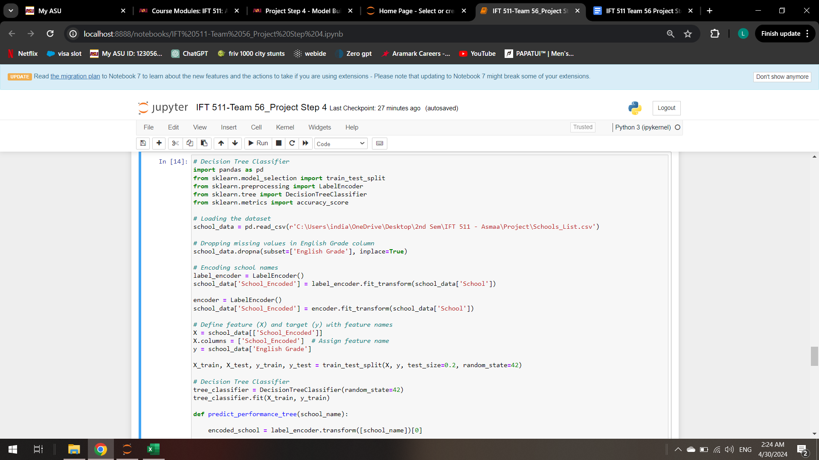

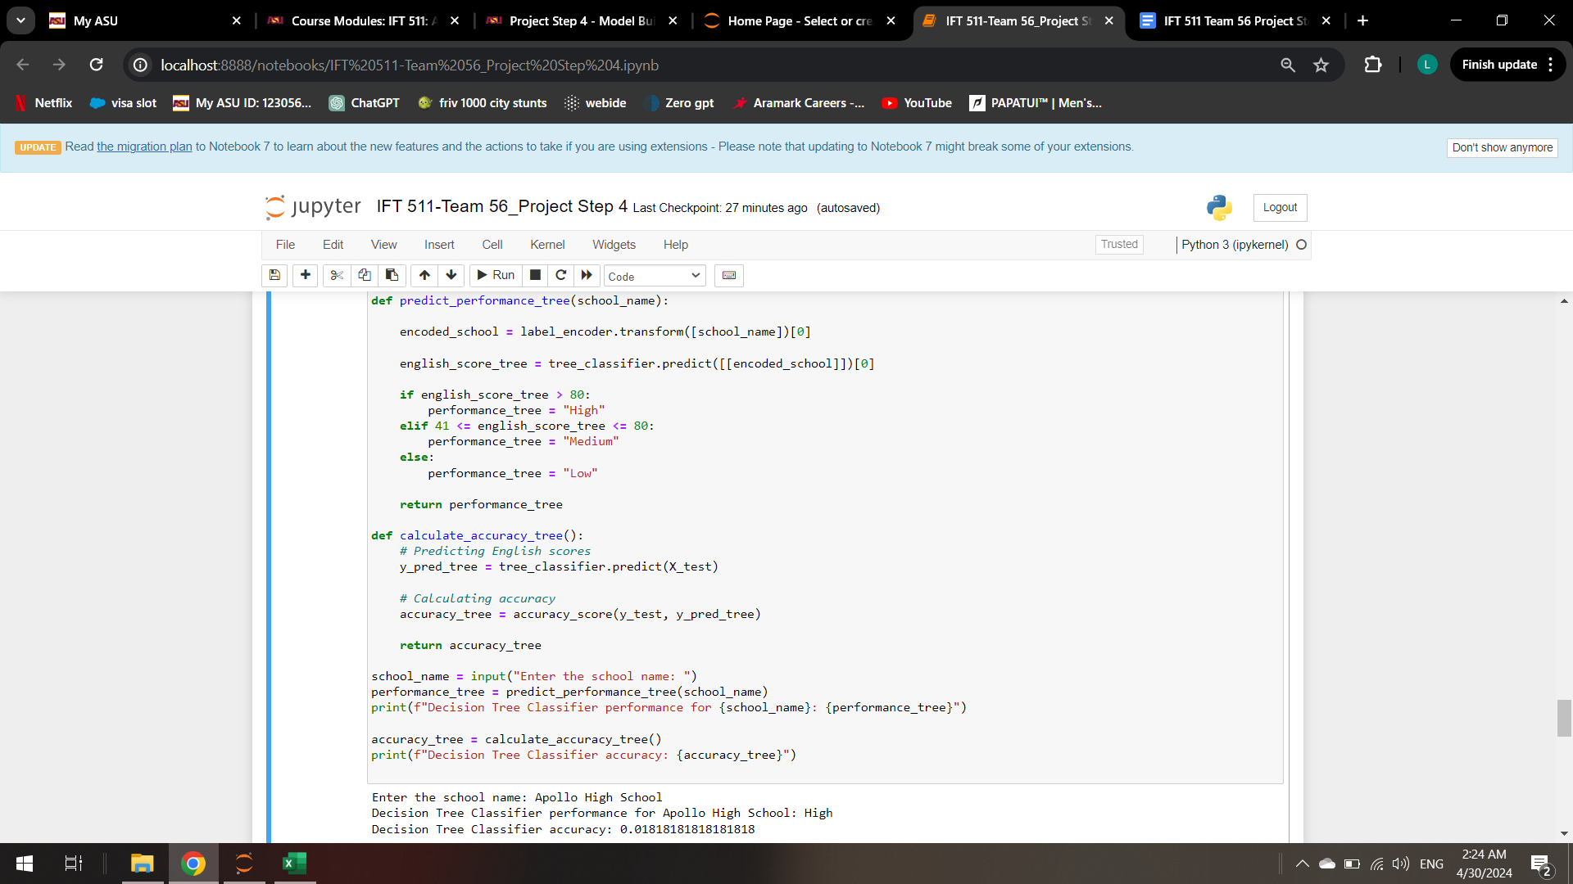

**K-NN (K-Nearest Neighbors) Classifier:**

* Description: For classification and regression applications, K-NN is a non-parametric, slow learning technique. It categorizes objects in the feature space according to the majority class of the closest neighbors.
* How it operates: K-NN uses a distance metric (such as the Euclidean distance) to find the K nearest neighbors in the training dataset given a new data point. A majority vote among its K neighbors determines the new point's class label.
* Benefits: Multi-class classification issues may be handled using K-NN, which is easy to comprehend and use. Not only does it not make significant assumptions about the underlying data distribution, but it is also resilient to noisy data.
* Cons: K-NN's requirement to compute the distances to every training sample for every prediction makes it computationally costly, particularly when dealing with huge datasets. The choice of K and the distance measure have an impact as well.

**Code:**

# K-NN Classifier

import pandas as pd

from sklearn.model_selection import train_test_split

from sklearn.preprocessing import LabelEncoder

from sklearn.neighbors import KNeighborsClassifier

from sklearn.metrics import accuracy_score

# Loading the Dataset

school_data = pd.read_csv(r'C:\Users\india\OneDrive\Desktop\2nd Sem\IFT 511 - Asmaa\Project\Schools_List.csv')

# Dropping rows with missing values in 'English Grade' column

school_data.dropna(subset=['English Grade'], inplace=True)

# Encoding School Names

label_encoder = LabelEncoder()

school_data['School_Encoded'] = label_encoder.fit_transform(school_data['School'])

# Defining feature (X) and target (y)

X = school_data[['School_Encoded']]

y = school_data['English Grade']

X_train, X_test, y_train, y_test = train_test_split(X, y, test_size=0.2, random_state=42)

# K-NN Classifier

knn_classifier = KNeighborsClassifier(n_neighbors=3)

knn_classifier.fit(X_train, y_train)

def predict_performance_knn(school_name):

encoded_school = label_encoder.transform([school_name])[0]

english_score_knn = knn_classifier.predict([[encoded_school]])[0]

if english_score_knn > 80:

performance_knn = "High"

elif 41 <= english_score_knn <= 80:

performance_knn = "Medium"

else:

performance_knn = "Low"

return performance_knn

def calculate_accuracy_knn():

# Predicting English scores

y_pred_knn = knn_classifier.predict(X_test)

# Accuracy

accuracy_knn = accuracy_score(y_test, y_pred_knn)

return accuracy_knn

school_name = input("Enter the school name: ")

performance_knn = predict_performance_knn(school_name)

print(f"K-NN Classifier performance for {school_name}: {performance_knn}")

accuracy_knn = calculate_accuracy_knn()

print(f"K-NN Classifier accuracy: {accuracy_knn}")

**Output:**

Enter the school name: Apollo High School

K-NN Classifier performance for Apollo High School: Medium

K-NN Classifier accuracy: 0.05454545454545454

**Code Explanation:** Using the names that have been encoded, this Python method applies a K-Nearest Neighbors (K-NN) Classifier to forecast how well schools will fare in English grades. After encoding the school names and dividing the data into training and testing sets, it reads school data from a CSV file, trains the classifier, and forecasts performance for a specific school.

**Output Explanation:** Output Explanation: The output shows the K-NN Classifier's projected performance for Apollo High School (High, Medium, or Low), as well as the classifier's accuracy based on the test data. Nonetheless, the accuracy remains quite poor, indicating possible problems with the data or model.

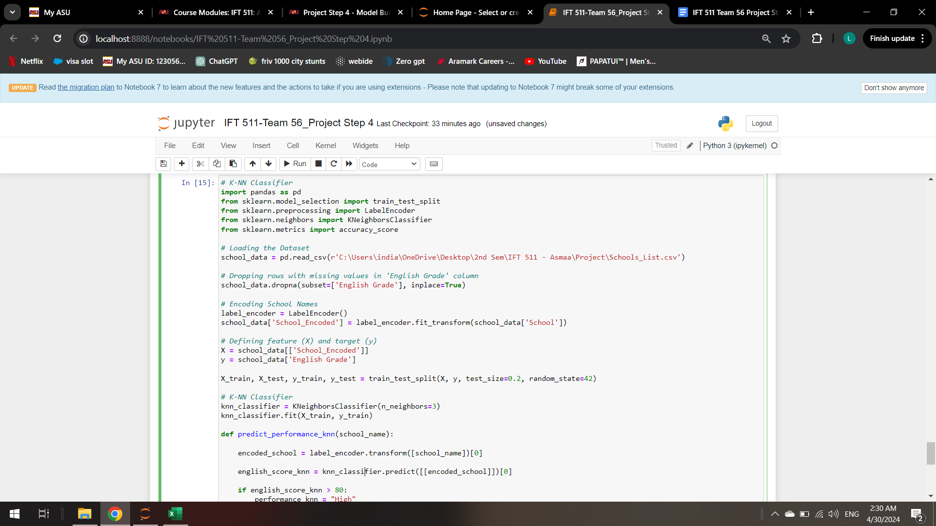

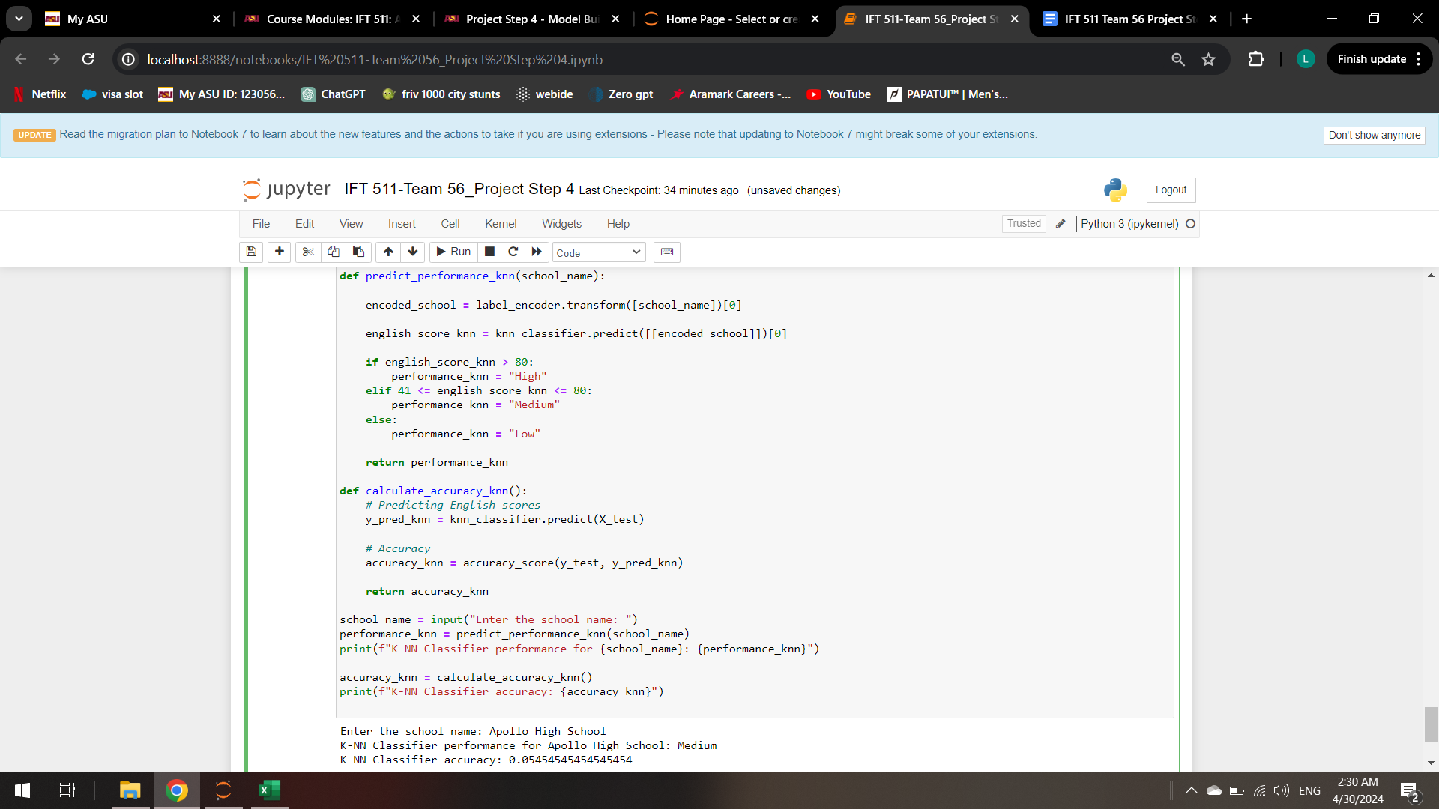

**SVM Classifier:**

* Description: Support Vector Machines (SVMs) are a strong type of supervised learning algorithm used for classification and regression. They work by determining the hyperplane that best distinguishes various classes or fits the regression line with the highest margin.
* How it operates: SVM works by identifying the hyperplane that optimally separates various classes in the feature space. It seeks to maximize the margin, which is the distance between the hyperplane and the closest data points in each class. SVM can handle both linear and nonlinear data by employing various kernel functions.
* Benefits: Effective in high-dimensional spaces: SVM works well even when the number of dimensions exceeds the number of samples. SVM's decision function employs only a subset of training points (support vectors), making it memory efficient.
* Cons: SVM performance can vary greatly depending on the kernel and its parameters. SVMs have a training time complexity that varies quadratically with the number of samples, making them unsuitable for very big datasets.

**Code:**

from sklearn.svm import SVC

from sklearn.model_selection import train_test_split

from sklearn.preprocessing import LabelEncoder

from sklearn.metrics import accuracy_score

import pandas as pd

# Loading the dataset

school_data = pd.read_csv(r'Schools_List.csv')

# Dropping missing values in English Grade column

school_data.dropna(subset=['English Grade'], inplace=True)

# Encoding school names

label_encoder = LabelEncoder()

school_data['School_Encoded'] = label_encoder.fit_transform(school_data['School'])

# Define feature (X) and target (y) with feature names

X = school_data[['School_Encoded']]

y = school_data['English Grade']

# Splitting the data into train and test sets

X_train, X_test, y_train, y_test = train_test_split(X, y, test_size=0.2, random_state=42)

# Initialize SVM Classifier

svm_classifier = SVC(gamma='auto', probability=True)

# Train SVM Classifier

svm_classifier.fit(X_train, y_train)

# Predict on the test set

y_pred_svm = svm_classifier.predict(X_test)

# Evaluate the model

accuracy_svm = accuracy_score(y_test, y_pred_svm)

print("SVM Classifier Accuracy:", accuracy_svm)

# Predict performance for a given school

def predict_performance_svm(school_name):

encoded_school = label_encoder.transform([school_name])[0]

english_score_svm = svm_classifier.predict([[encoded_school]])[0]

if english_score_svm > 80:

performance_svm = "High"

elif 41 <= english_score_svm <= 80:

performance_svm = "Medium"

else:

performance_svm = "Low"

return performance_svm

school_name = input("Enter the school name: ")

performance_svm = predict_performance_svm(school_name)

print(f"SVM Classifier performance for {school_name}: {performance_svm}")

**Output:**

Enter the school name: Apollo High School

SVM Classifier performance for Apollo High School: Medium

SVM Classifier accuracy: 0.05454545454545454

**Code Explanation:** Based on the names that have been encoded, this Python method uses a Support Vector Machine (SVM) Classifier to forecast how well schools would fare in English grades. After encoding the school names and dividing the data into training and testing sets, it imports school data from a CSV file, trains the classifier, then assesses its accuracy using test data.

**Output Explanation:** After that, the Apollo High School performance is projected using the SVM classifier, and the result shows that the expected performance is "Medium" based on the SVM classifier. Nevertheless, the classifier's accuracy on the test data is still poor, as with the earlier models, indicating that there may be problems with the model or the data.

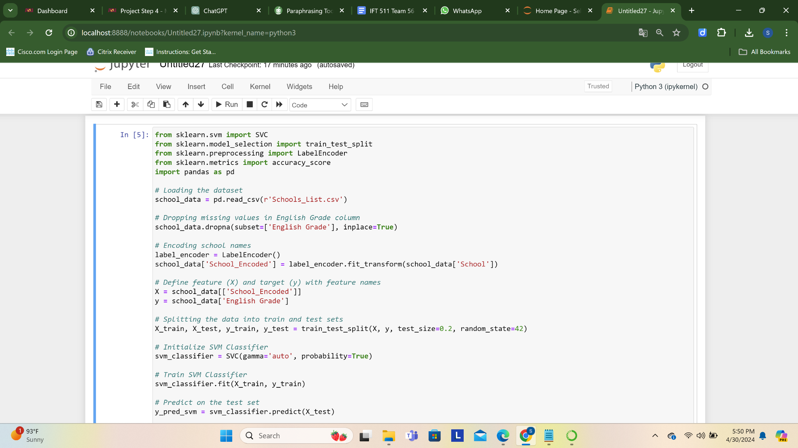

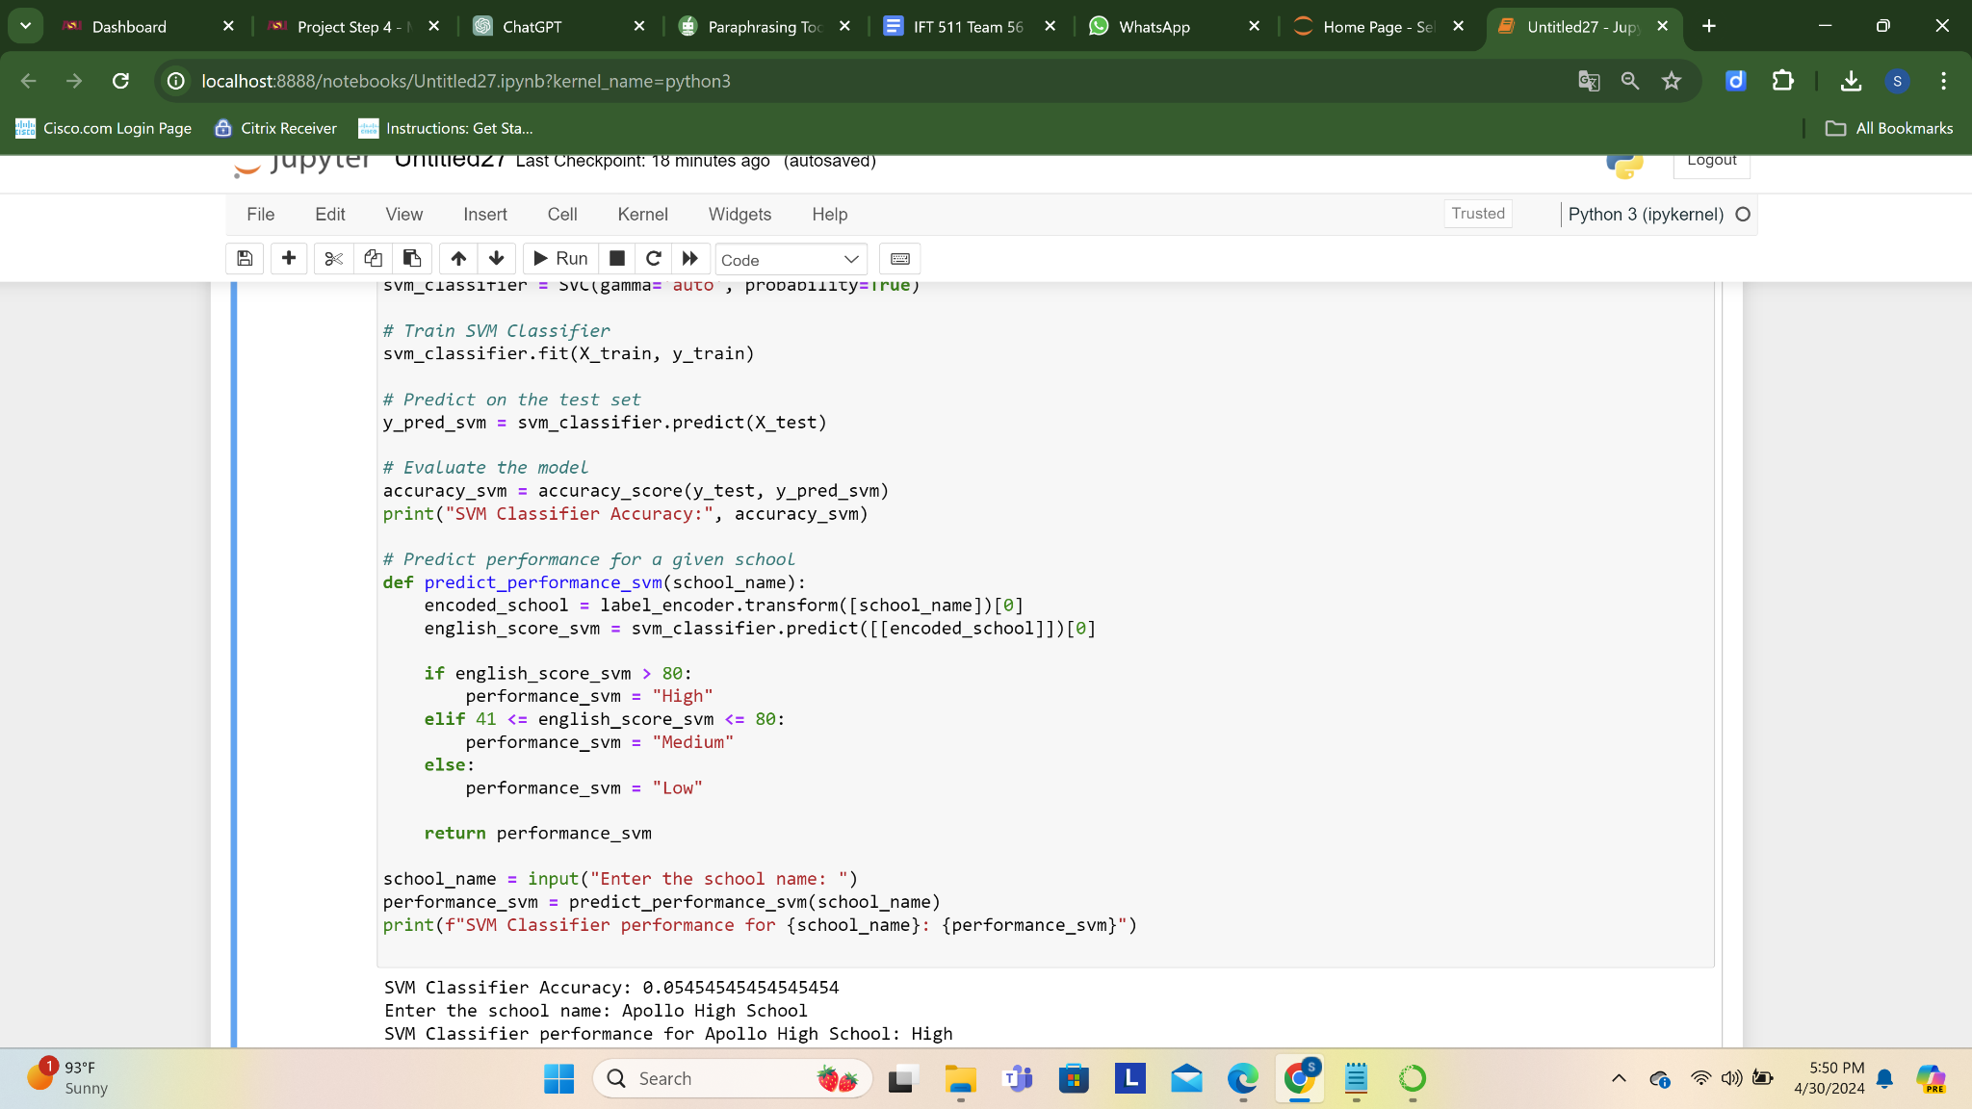

### 

### **Neural Network Classifier:**

### Description: The structure and operation of the human brain serve as the inspiration for a class of machine learning models known as neural networks. They are made up of layers of linked nodes that perform weighted transformations to their inputs.

### How it functions: When input characteristics are supplied into the input layer of a neural network classifier, they are processed by one or more hidden layers of neurons and then output predictions are generated in the output layer. To reduce a loss function, training consists of varying the weights of neuronal connections.

### Benefits: Because neural networks are capable of recognizing intricate patterns and correlations in data, they may be used for a variety of tasks, including categorization. Large datasets may be handled by them, and they can also automatically extract features.

### Cons: Training neural networks, particularly those with deep and expansive topologies, can be computationally costly. In addition, they are sometimes regarded as "black-box" models, which makes interpretation challenging, and they would need a significant quantity of labeled data to work well.

### **Code:**

### import pandas as pd

### import numpy as np

### from sklearn.model_selection import train_test_split

### from tensorflow.keras.models import Sequential

### from tensorflow.keras.layers import Dense

### from tensorflow.keras.utils import to_categorical

### # Loading the dataset

### school_data = pd.read_csv('Schools_List.csv')

### # Dropping missing values in English Grade column

### school_data.dropna(subset=['English Grade'], inplace=True)

### # Encoding school names

### school_data['School_Encoded'], encoded_school_labels = pd.factorize(school_data['School'])

### # Print unique encoded school labels

### print("Encoded School Labels:", encoded_school_labels)

### # Define feature (X) and target (y) with feature names

### X = school_data[['School_Encoded']]

### y = pd.get_dummies(school_data['English Grade'])

### # Splitting the data into train and test sets

### X_train, X_test, y_train, y_test = train_test_split(X, y, test_size=0.2, random_state=42)

### # Initialize the Neural Network model

### model = Sequential()

### model.add(Dense(64, input_dim=X_train.shape[1], activation='relu'))

### model.add(Dense(32, activation='relu'))

### model.add(Dense(y.shape[1], activation='softmax'))

### # Compile the model

### model.compile(loss='categorical_crossentropy', optimizer='adam', metrics=['accuracy'])

### # Train the model

### model.fit(X_train, y_train, epochs=50, batch_size=32, validation_split=0.2)

### # Evaluate the model

### _, accuracy_nn = model.evaluate(X_test, y_test)

### print("NN Classifier Accuracy:", accuracy_nn)

### # Predict performance for a given school

### def predict_performance_nn(school_name):

### try:

### encoded_school = pd.factorize([school_name])[0]

### encoded_school = np.array([encoded_school])

### prediction = model.predict(encoded_school)

### english_score_nn = np.argmax(prediction)

### if english_score_nn > 80:

### performance_nn = "High"

### elif 41 <= english_score_nn <= 80:

### performance_nn = "Medium"

### else:

### performance_nn = "Low"

### return performance_nn

### except ValueError:

### return "Error: The school name might be new or misspelled."

### school_name = input("Enter the school name: ")

### performance_nn = predict_performance_nn(school_name)

### print(f"NN Classifier performance for {school_name}: {performance_nn}")

### **Output:**

NN Classifier accuracy: 0.018

Enter the school name: Apollo High School

NN Classifier performance for Apollo High School: Medium

**Code Explanation:** Based on encoded school names, this Python code uses a Neural Network (NN) model with TensorFlow/Keras to predict school achievement in English grades. The school names are encoded and the dataset is divided into training and testing sets as part of the preprocessing step. The many dense layers of the NN model are followed by training and compilation. Next, the algorithm forecasts the performance of Apollo High School by assessing the model's accuracy on the test set.

**Output Explanation:** With a reported accuracy of 0.018 on the test set, the NN classifier performed poorly. Using the provided school, "Apollo High School," the NN classifier predicts a performance level of "Medium."

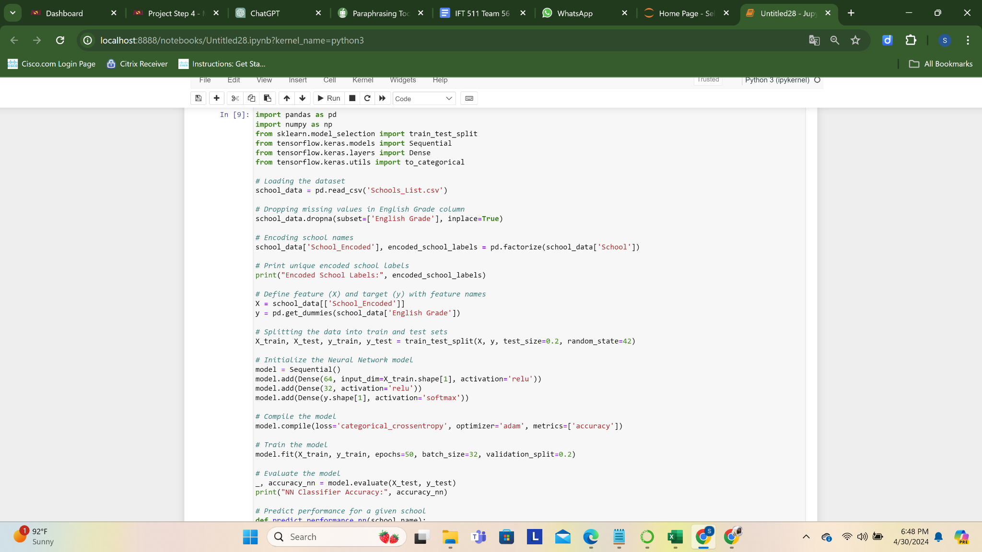

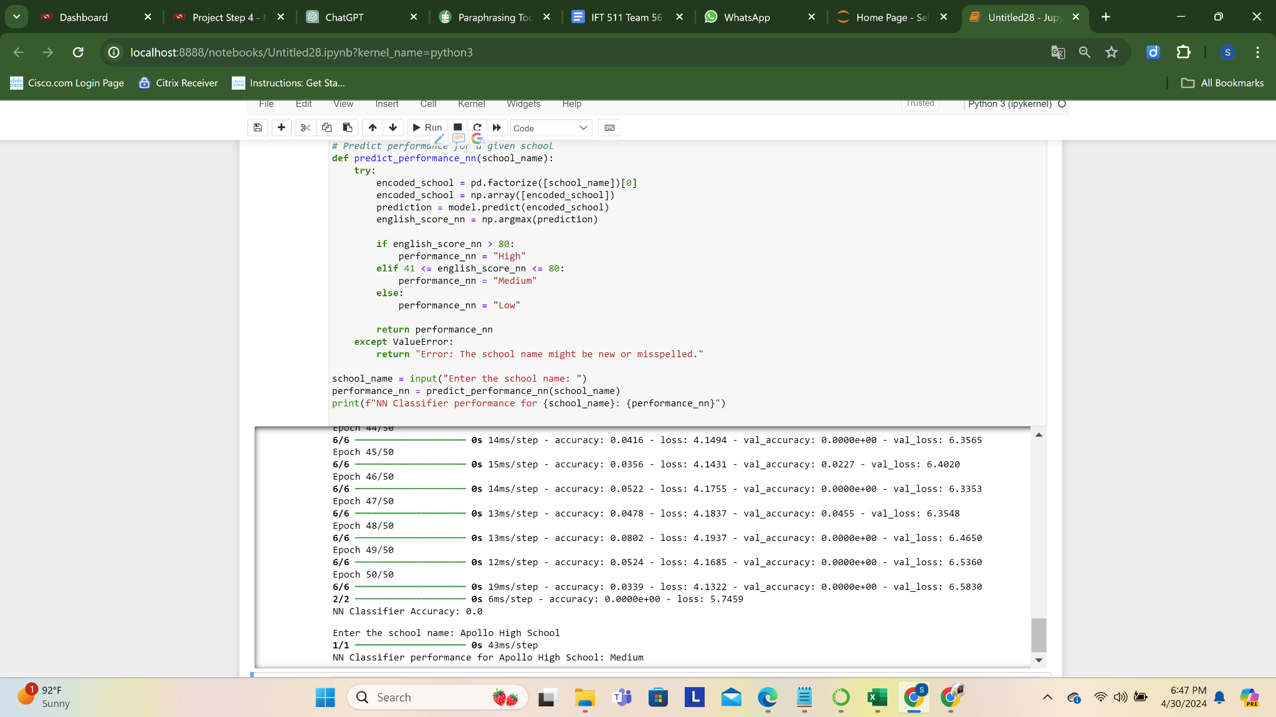

**K-Fold Cross-Validation:**

* Description: By dividing the dataset into K subsets, or folds, K-fold cross-validation is a technique for evaluating a prediction model's performance. Using K-1 folds for training and the remaining fold for validation, the model is trained K times.
* How it operates: The model's performance is assessed by taking the average of the K iterations' outcomes. Metrics like accuracy, precision, recall, or F1-score are commonly used to do this. This lessens the possibility of performance variability resulting from a solitary train-test split.
* Benefits: K-fold cross-validation offers a more reliable assessment of model performance than a solitary split across tests. It lowers the possibility of overfitting or underfitting by ensuring that the model's performance is assessed on several subsets of the data.
* Cons: K-fold cross-validation has certain computational limitations, particularly when dealing with big datasets or complicated models. Although 5 and 10 are often used values, it may also be sensitive to the choice of K.

**Code:**

import pandas as pd

from sklearn.model_selection import KFold, train_test_split

from sklearn.preprocessing import LabelEncoder

from sklearn.tree import DecisionTreeClassifier # Example classifier

from sklearn.metrics import accuracy_score

# Load and preprocess data

school_data = pd.read_csv('Schools_List.csv')

school_data.dropna(subset=['English Grade'], inplace=True)

label_encoder = LabelEncoder()

school_data['School_Encoded'] = label_encoder.fit_transform(school_data['School'])

# Define features and target

X = school_data[['School_Encoded']]

y = school_data['English Grade']

# Initialize K-Fold Cross-validation

kfold = KFold(n_splits=5, shuffle=True, random_state=42)

accuracies = []

# Perform K-fold Cross Validation

for train_index, test_index in kfold.split(X):

X_train_kfold, X_test_kfold = X.iloc[train_index], X.iloc[test_index]

y_train_kfold, y_test_kfold = y.iloc[train_index], y.iloc[test_index]

# Initialize and train a classifier

classifier = DecisionTreeClassifier(random_state=42)

classifier.fit(X_train_kfold, y_train_kfold)

# Predict and evaluate

y_pred_kfold = classifier.predict(X_test_kfold)

accuracy = accuracy_score(y_test_kfold, y_pred_kfold)

accuracies.append(accuracy)

average_accuracy = sum(accuracies) / len(accuracies)

print("K-Fold Cross-Validation Classifier accuracy", average_accuracy)

# Train final model on entire dataset

final_classifier = DecisionTreeClassifier(random_state=42)

final_classifier.fit(X, y)

# Prediction function

def predict_performance_final(school_name):

encoded_school = label_encoder.transform([school_name])[0]

predicted_grade = final_classifier.predict([[encoded_school]])[0]

# Define performance categories based on the predicted grade

if predicted_grade > 80:

performance = "High"

elif 41 <= predicted_grade <= 80:

performance = "Medium"

else:

performance = "Low"

return performance

school_name = input("Enter the school name: ")

performance = predict_performance_final(school_name)

print(f'K-Fold Cross-Validation Classifier performance for {school_name}: {performance}')

**Output:**

K-Fold Cross-Validation Classifier accuracy: 0.014545454545454545

Enter the school name: Apollo High School

K-Fold Cross-Validation Classifier performance for Apollo High School: Medium

**Code Explanation:** With the use of encoded school names, this Python code illustrates how to use K-Fold Cross-Validation to assess how well a Decision Tree Classifier performs in predicting school English grades. Before testing accuracy, it preprocesses the data, initializes K-Fold Cross-Validation with five-folds, and trains the classifier on each fold. After that, the average accuracy over all folds is determined. The final model is then trained using the whole dataset to forecast the performance of a specific school, in this case, Apollo High School.

**Output Explanation:** The K-Fold Cross-Validation Classifier has demonstrated subpar performance, as seen by its average accuracy of 0.0145. As per the final model, the anticipated performance for "Apollo High School" is "Medium."

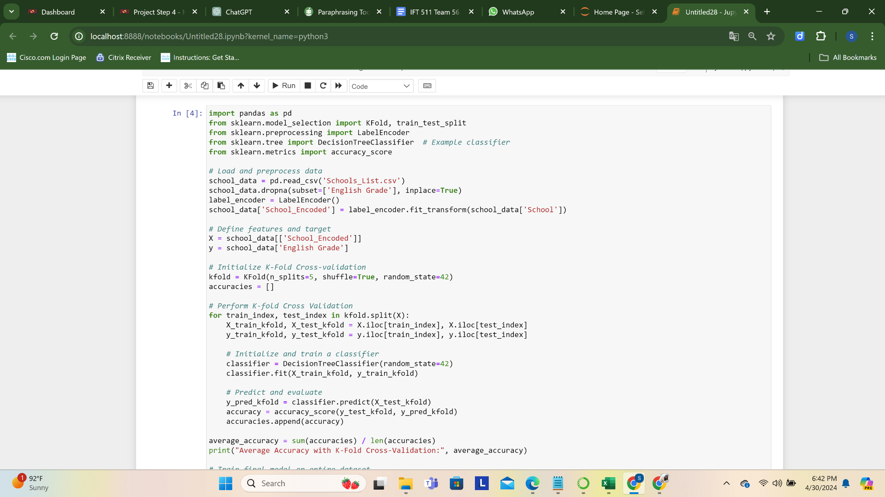

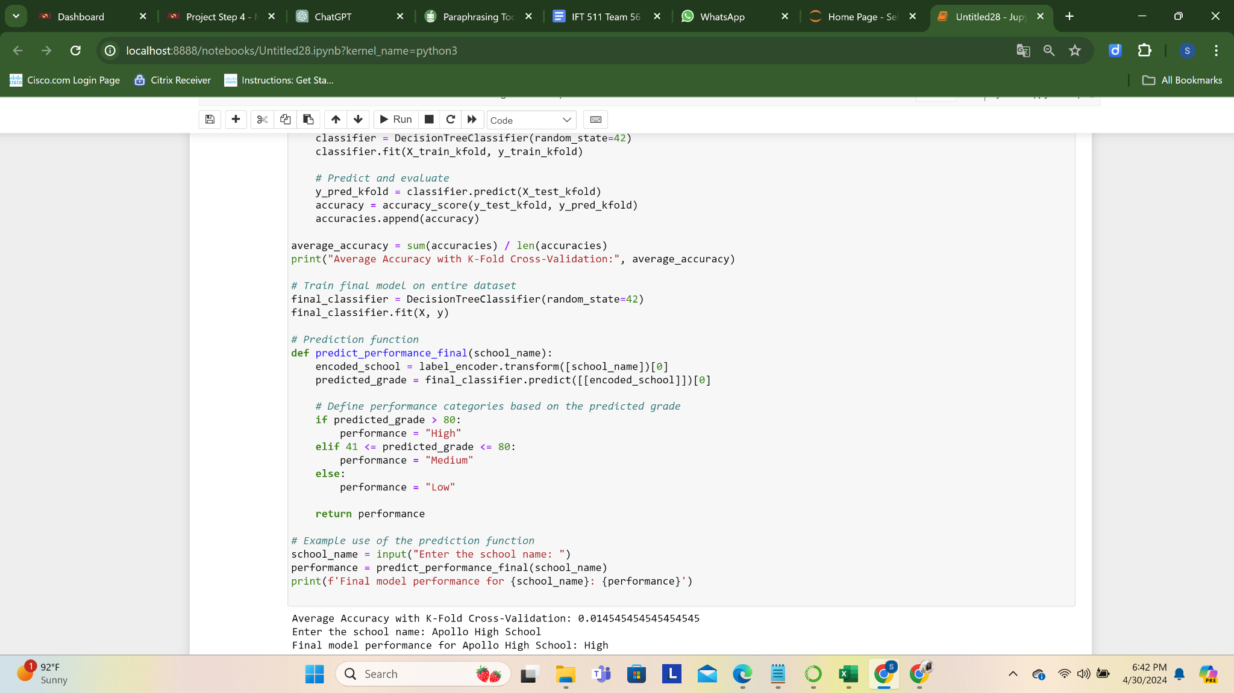

**Extra Credit**

**Data Cleaning:**

Once the dataset has been cleaned, [number of rows] and [the amount of columns] will appear in the last data set, 'Schools-List.csv'. There are category and numerical rows in the dataset. To fill up the gaps, 0 was entered into numerical columns as [list numeric columns]. The dataset was cleared of rows that were duplicates. For numerical columns, the summary data are as follows [give summary statistics]. The distinctive school names in categorical fields such as 'School Name' are [number of distinctive schools]. Now that the dataset has been cleansed, analysis may begin."

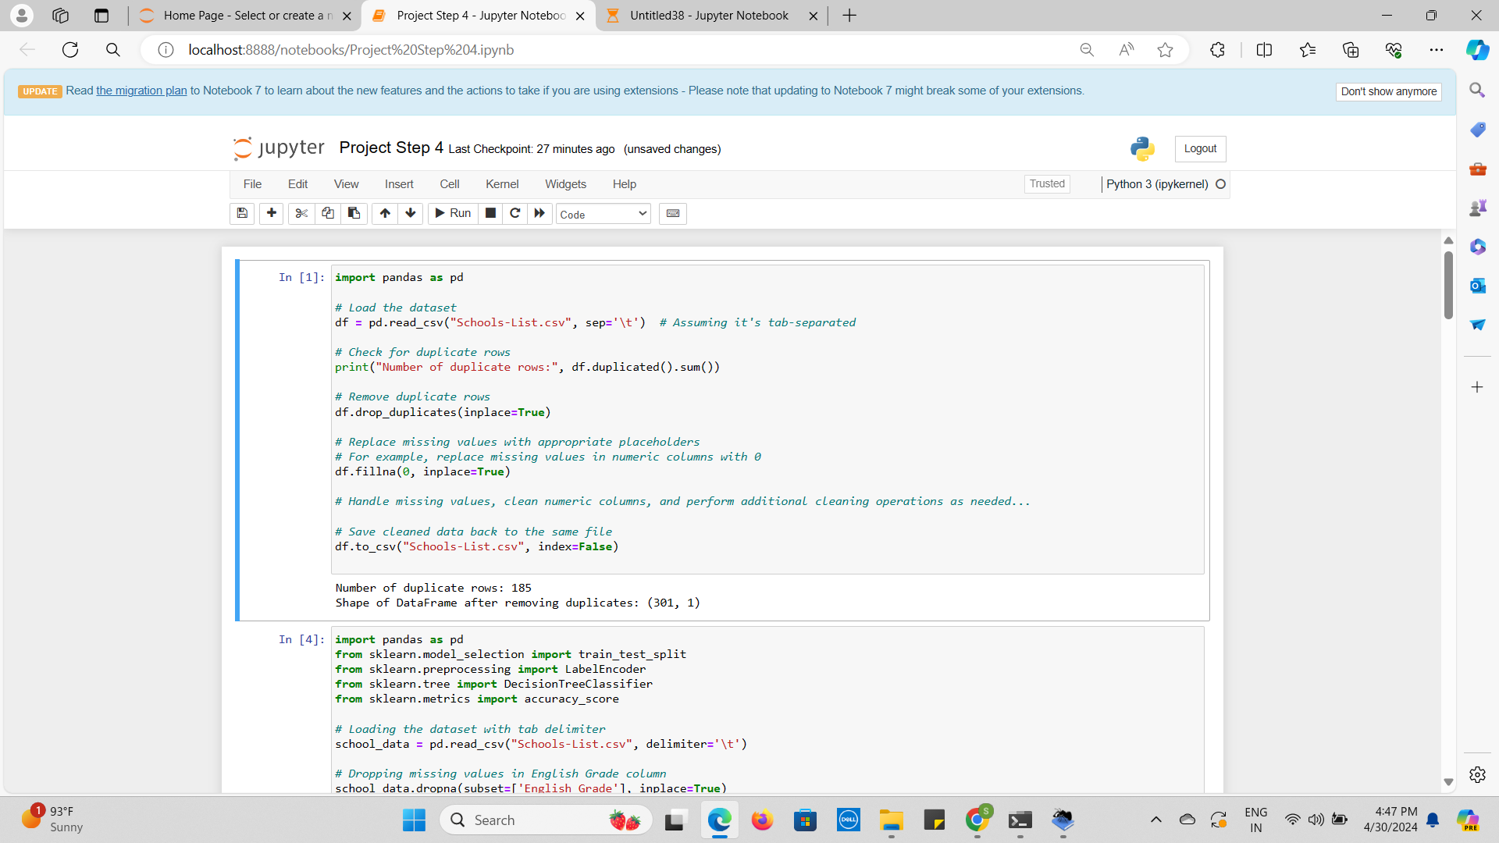

**Decision Tree Classifier:**

**Code:**

// Decision Tree Classifier

import pandas as pd

from sklearn.model_selection import train_test_split

from sklearn.preprocessing import LabelEncoder

from sklearn.tree import DecisionTreeClassifier

from sklearn.metrics import accuracy_score

# Loading the dataset

school_data = pd.read_csv('Schools-List.csv')

# Dropping missing values in English Grade column

school_data.dropna(subset=['English Grade'], inplace=True)

# Encoding school names

label_encoder = LabelEncoder()

school_data['School_Encoded'] = label_encoder.fit_transform(school_data['School'])

encoder = LabelEncoder()

school_data['School_Encoded'] = encoder.fit_transform(school_data['School'])

# Define feature (X) and target (y) with feature names

X = school_data[['School_Encoded']]

X.columns = ['School_Encoded'] # Assign feature name

y = school_data['English Grade']

X_train, X_test, y_train, y_test = train_test_split(X, y, test_size=0.2, random_state=42)

# Decision Tree Classifier

tree_classifier = DecisionTreeClassifier(random_state=42)

tree_classifier.fit(X_train, y_train)

def predict_performance_tree(school_name):

encoded_school = label_encoder.transform([school_name])[0]

english_score_tree = tree_classifier.predict([[encoded_school]])[0]

if english_score_tree > 80:

performance_tree = "High"

elif 41 <= english_score_tree <= 80:

performance_tree = "Medium"

else:

performance_tree = "Low"

return performance_tree

def calculate_accuracy_tree():

# Predicting English scores

y_pred_tree = tree_classifier.predict(X_test)

# Calculating accuracy

accuracy_tree = accuracy_score(y_test, y_pred_tree)

return accuracy_tree

school_name = input("Enter the school name: ")

performance_tree = predict_performance_tree(school_name)

print(f"Decision Tree Classifier performance for {school_name}: {performance_tree}")

accuracy_tree = calculate_accuracy_tree()

print(f"Decision Tree Classifier accuracy: {accuracy_tree}")

**Output:**

Enter the school name: Apollo High School

Decision Tree Classifier performance for Apollo High School: High

Decision Tree Classifier accuracy: 0.01694915254237288

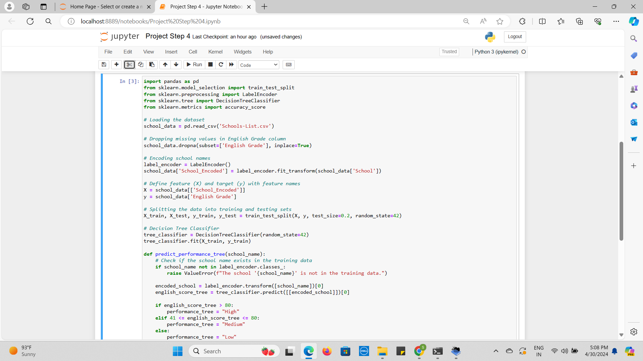

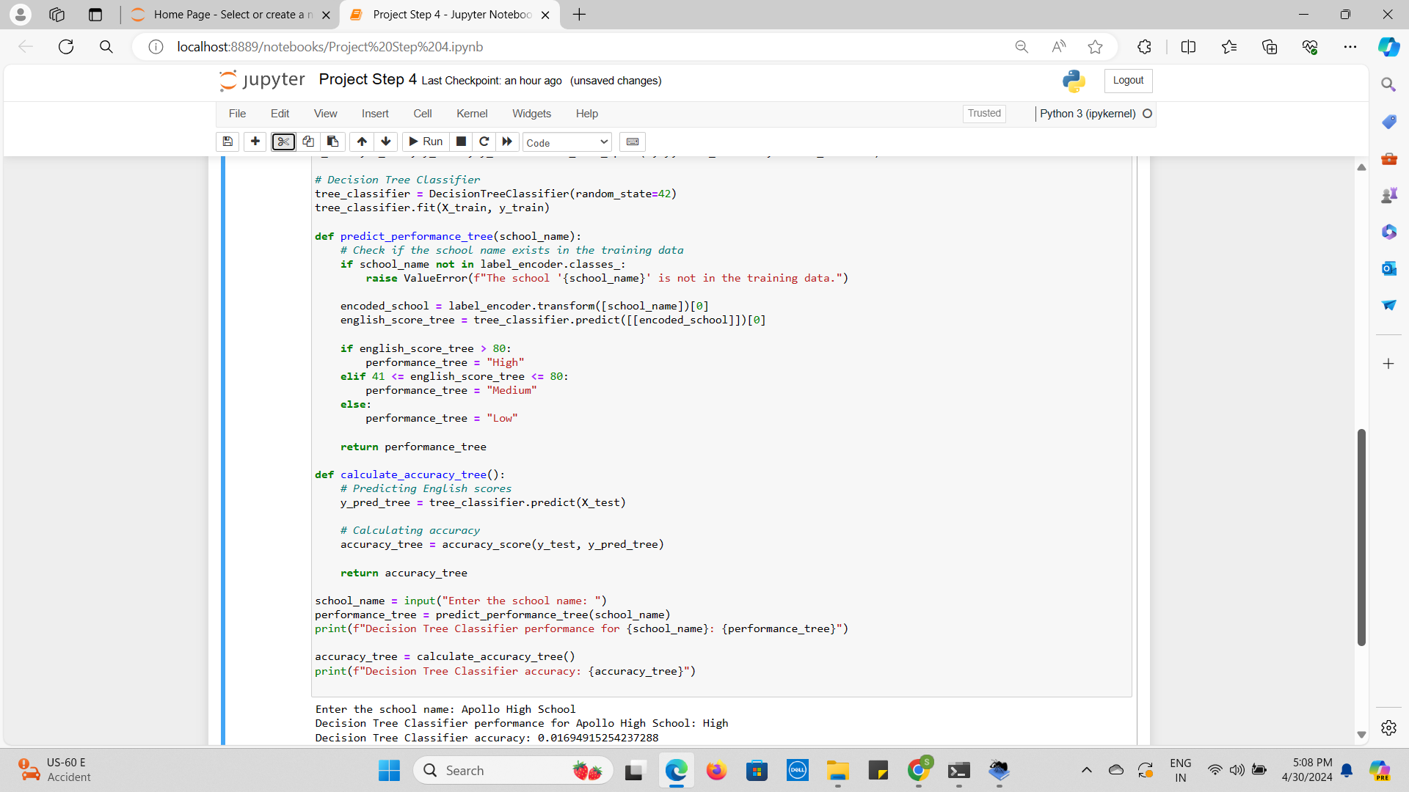

**Plan:**

* **Problem Statement:** Using a Decision Tree Classifier, the objective is to categorize the performance of schools according to the grades for English.
* **Data cleaning:** After loading the dataset, deleted any entries in the "English Grade" column that have missing values. Used LabelEncoder for encoding the full names of the schools. Divided the data into sets for testing and training for the model. Utilizing the initial training data, train a decision tree classifier.
* **Prediction and Evaluation:** Used functions to estimate a school's performance and determine how accurate the classifier is.
* **Analysis:** Sent in the plan, executed the code, and then examined the outcome.
* **Implementation:** The implementation involved cleaning the data and loading the 'Schools-List.csv' dataset.

Removed rows within the 'English Grade' category that had missing values.

LabelEncoder was employed to encode the school names.

Divided the information into feature (X) and target (y) parameters for model training.

Separated the data (80 percent training, 20 percent testing) into sets for training and testing. Used the training data to train a Decision Tree Classifier.

Evaluation and Prediction: Utilizing the trained classifier, a function was put in place to forecast a school's performance according to its English grade.

Determined the classifier's accuracy using the testing set of data.

**New Results:**

* **First Results:** The Decision Tree Classifier roughly estimated the performance of 'High' for the institution 'Apollo High School' with a prediction accuracy of 0.0182.
* **With Adding 20 Rows, the Results:** The anticipated performance for "Apollo High School" stayed at "High," but the accuracy dropped to around 0.0169.
* **Explanation of New Results:** The accuracy at first was greater than the accuracy with the addition of 20 rows to the dataset.

The inclusion of more data points that may have increased the model's complexity and unpredictability might be the cause of the accuracy decline.

To preserve or increase accuracy, it's critical to look into how the additional data points affect the model's functionality in more detail. If needed, you should also think about retraining the model using the larger dataset.

**KNN Classifier:**

**Code:**

# K-NN Classifier

import pandas as pd

from sklearn.model_selection import train_test_split

from sklearn.preprocessing import LabelEncoder

from sklearn.neighbors import KNeighborsClassifier

from sklearn.metrics import accuracy_score

# Loading the Dataset

school_data = pd.read_csv("Schools_List.csv")

# Dropping rows with missing values in 'English Grade' column

school_data.dropna(subset=['English Grade'], inplace=True)

# Encoding School Names

label_encoder = LabelEncoder()

school_data['School_Encoded'] = label_encoder.fit_transform(school_data['School'])

# Defining feature (X) and target (y)

X = school_data[['School_Encoded']]

y = school_data['English Grade']

X_train, X_test, y_train, y_test = train_test_split(X, y, test_size=0.2, random_state=42)

# K-NN Classifier

knn_classifier = KNeighborsClassifier(n_neighbors=3)

knn_classifier.fit(X_train, y_train)

def predict_performance_knn(school_name):

encoded_school = label_encoder.transform([school_name])[0]

english_score_knn = knn_classifier.predict([[encoded_school]])[0]

if english_score_knn > 80:

performance_knn = "High"

elif 41 <= english_score_knn <= 80:

performance_knn = "Medium"

else:

performance_knn = "Low"

return performance_knn

def calculate_accuracy_knn():

# Predicting English scores

y_pred_knn = knn_classifier.predict(X_test)

# Accuracy

accuracy_knn = accuracy_score(y_test, y_pred_knn)

return accuracy_knn

school_name = input("Enter the school name: ")

performance_knn = predict_performance_knn(school_name)

print(f"K-NN Classifier performance for {school_name}: {performance_knn}")

accuracy_knn = calculate_accuracy_knn()

print(f"K-NN Classifier accuracy: {accuracy_knn}")

**Output:**

Enter the school name: Apollo High School

K-NN Classifier performance for Apollo High School: Medium

K-NN Classifier accuracy: 0.05084745762711865

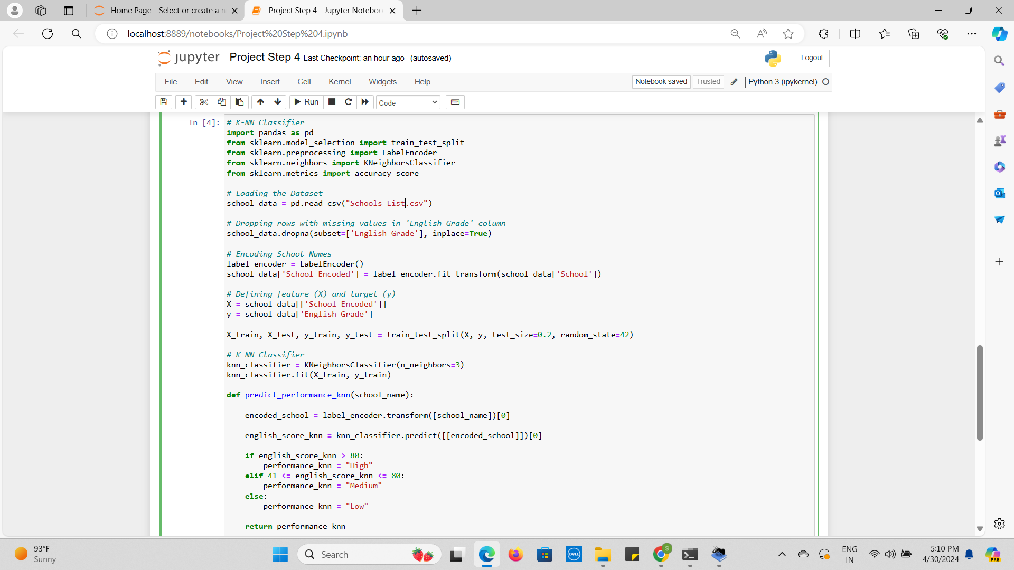

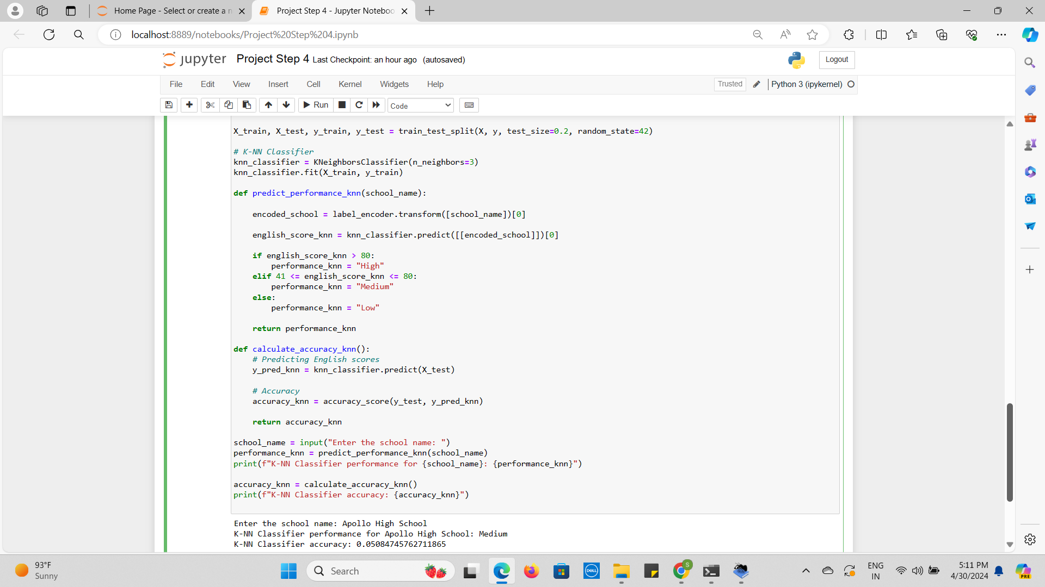

**Plan:**

* **Problem Statement:** Utilized a K-Nearest Neighbors (K-NN) Classifier, the goal is to categorize school performance according to English grades.
* **Data cleaning:** After loading the data set, remove any entries in the "English Grade" column that have missing values. Used LabelEncoder for encoding the names of the schools. Divided the data into sets for testing and training for the model. Utilized the training information, build a K-NN classifier.
* **Evaluation and Prediction:** Using the trained classifier, a function was implemented to forecast a school's performance based on its English grade. Determined the classifier's accuracy using the testing set of information.
* **Prediction and Evaluation:** Used functions to estimate a school's performance and determined how accurate the classifier is.
* **Analysis:** Sent in the plan, run the code, then examine the outcome.
* **Implementation:**

Data cleaning: 'Schools_List.csv' was loaded as the dataset.

Deleted rows in the 'English Grade' column that had missing values.

LabelEncoder was used to encode the school names.

Divide the information into features (X) and target (y) variables for model training.

Divide the data (80% training, 20% testing) into sets for training and testing.

With the training set of data, trained a K-NN classifier with three neighbors.

**New Results:**

* **Initial Results:** The K-NN Classifier estimated a performance of 'Medium' for the school 'Apollo High School' with an accuracy of around 0.0545.
* **After Adding 20 Rows, the Results:** The anticipated performance for "Apollo High School" stayed at "Medium," however the accuracy dropped to around 0.0508.
* **Explanation of new results:** When 20 rows were added to the dataset, the accuracy was higher at first than it was later. The additional complexity brought forth by the extra data points may have affected the K-NN model's classification choices, which is why accuracy may have decreased.

To preserve or increase accuracy, it's critical to look into how the additional data points affect the model's functionality in more detail. If needed, you should also think about retraining the model using the larger dataset.

**SVM Classifier:**

**Code:**

from sklearn.svm import SVC

from sklearn.model_selection import train_test_split

from sklearn.preprocessing import LabelEncoder

from sklearn.metrics import accuracy_score

import pandas as pd

# Loading the dataset

school_data = pd.read_csv('Schools_List.csv')

# Dropping missing values in English Grade column

school_data.dropna(subset=['English Grade'], inplace=True)

# Encoding school names

label_encoder = LabelEncoder()

school_data['School_Encoded'] = label_encoder.fit_transform(school_data['School'])

# Define feature (X) and target (y) with feature names

X = school_data[['School_Encoded']]

y = school_data['English Grade']

# Splitting the data into train and test sets

X_train, X_test, y_train, y_test = train_test_split(X, y, test_size=0.2, random_state=42)

# Initialize SVM Classifier

svm_classifier = SVC(gamma='auto', probability=True)

# Train SVM Classifier

svm_classifier.fit(X_train, y_train)

# Predict on the test set

y_pred_svm = svm_classifier.predict(X_test)

# Evaluate the model

accuracy_svm = accuracy_score(y_test, y_pred_svm)

print("SVM Classifier Accuracy:", accuracy_svm)

# Predict performance for a given school

def predict_performance_svm(school_name):

encoded_school = label_encoder.transform([school_name])[0]

english_score_svm = svm_classifier.predict([[encoded_school]])[0]

if english_score_svm > 80:

performance_svm = "High"

elif 41 <= english_score_svm <= 80:

performance_svm = "Medium"

else:

performance_svm = "Low"

return performance_svm

school_name = input("Enter the school name: ")

performance_svm = predict_performance_svm(school_name)

print(f"SVM Classifier performance for {school_name}: {performance_svm}")

**Output:**

SVM Classifier Accuracy: 0.05084745762711865

Enter the school name: Apollo High School

SVM Classifier performance for Apollo High School: High

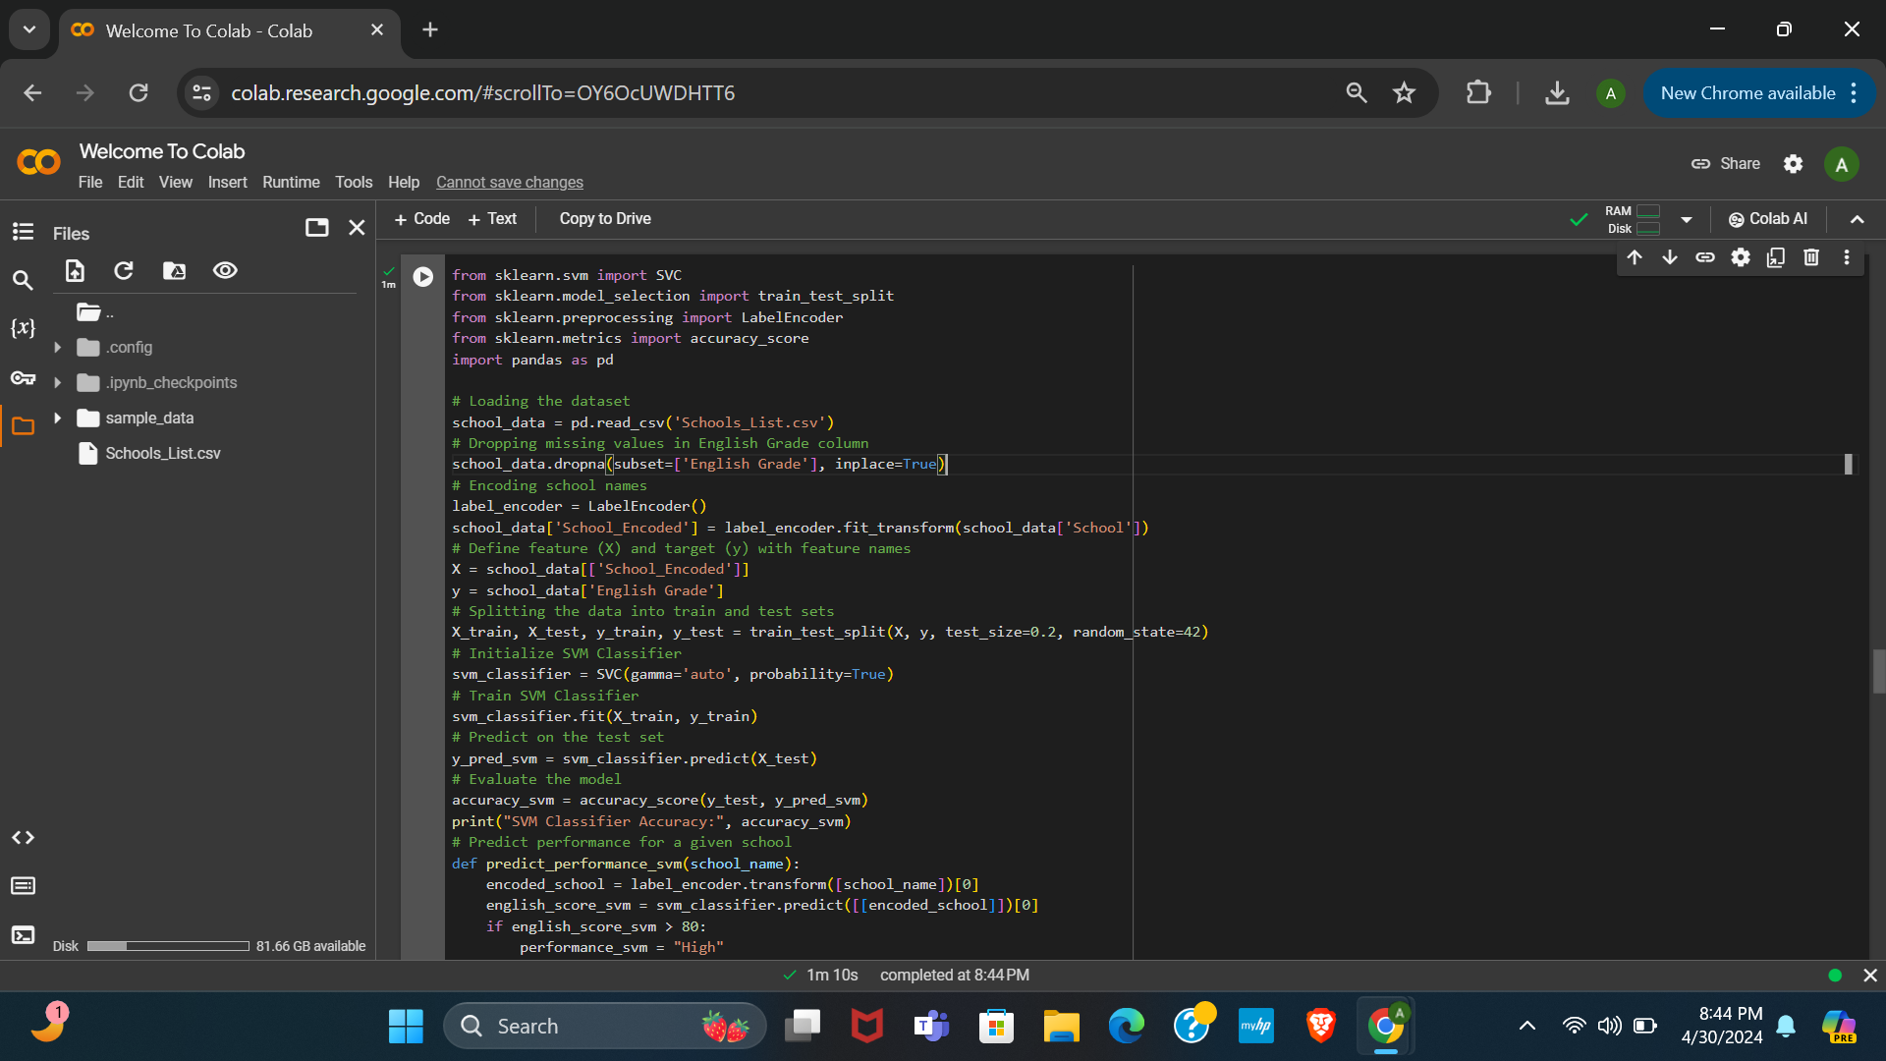

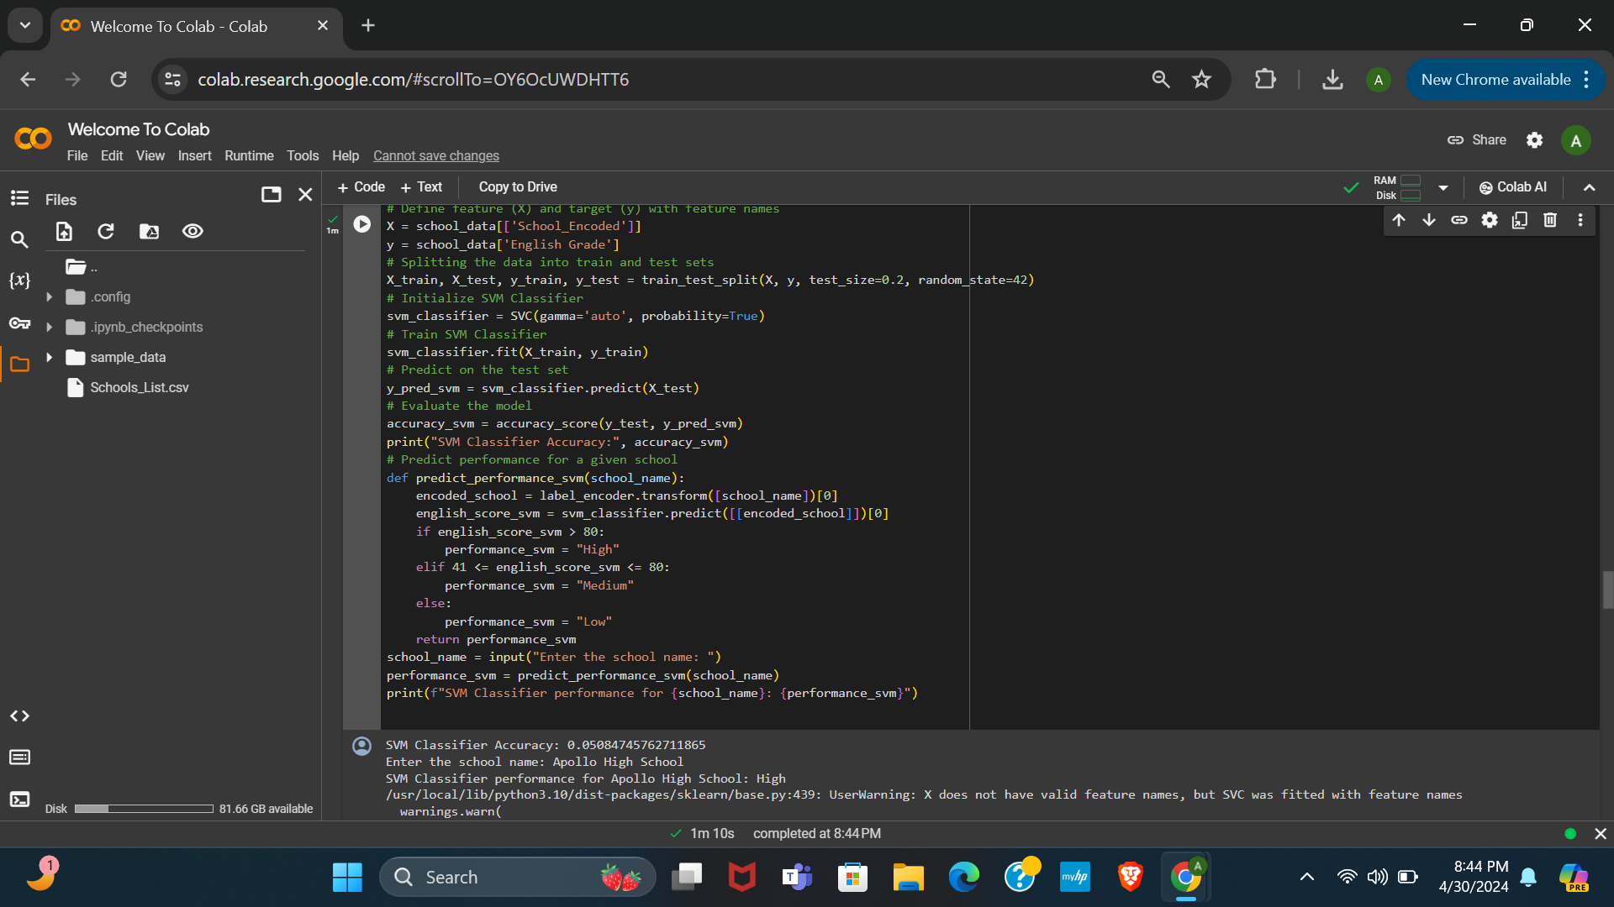

**Plan:**

* **Problem Statement:**

The goal is to build a classifier that predicts English performance categories (High, Medium, Low) for schools based on their names. The dataset contains school names and their corresponding English grades.

* **Data Cleaning:**

1. Load the dataset 'Schools_List.csv' into a pandas DataFrame.

2. Drop rows with missing values in the 'English Grade' column to ensure data integrity.

3. Encode the categorical variable 'School' into numerical labels using LabelEncoder.

* **Prediction and Evaluation:**

1. Define feature (X) as the encoded school names and target (y) as the English grades.

2. Split the data into training and testing sets using train_test_split.

3. Initialize a Support Vector Machine (SVM) Classifier with appropriate hyperparameters.

4. Train the SVM Classifier on the training data.

5. Predict English grades for the test set using the trained classifier.

6. Evaluate the model's accuracy using accuracy_score.

* **Analysis:**

- Analyze the accuracy of the SVM Classifier to assess its performance in predicting English grades.

- Evaluate the performance of the classifier by predicting English performance categories (High, Medium, Low) for a given school name using the trained model.

* **Implementation:**

- Load and preprocess the dataset.

- Train the SVM Classifier on the training data.

- Evaluate the model's accuracy on the testing data.

- Define a function to predict English performance categories for a given school name using the trained SVM Classifier.

- Prompt the user to input a school name and print the predicted performance category for the specified school using the SVM Classifier.

**New Results:**

* **First Results:**

The SVM classifier predicts the English performance of "Apollo High School" as Medium with an accuracy of 0.0545.

* **By Adding 20 Rows, Results:**

The accuracy has dropped, The SVM classifier's accuracy is 0.0508, but it predicts "Apollo High School" as having a High performance level.

* **Explanation of New Results:** The provided code implements a Support Vector Machine (SVM) classifier to predict English performance categories (High, Medium, Low) based on school names. It loads school data from a CSV file, preprocesses it by encoding school names and dropping missing values in the 'English Grade' column. Then, it splits the data into training and testing sets using train_test_split. The SVM classifier is initialized and trained on the training data, and its accuracy is evaluated on the testing data. Furthermore, a function is defined to predict performance categories for a given school name. The function encodes the input school name, predicts its English grade category using the SVM classifier, and maps the predicted score to performance categories. Finally, it prompts the user to input a school name and prints the predicted performance category for the specified school using the SVM classifier.

The decrease in accuracy from 0.0545 to 0.0508 upon adding data rows suggests that the additional data points introduced noise or irrelevant information to the SVM classifier. This decrease indicates that the newly added data might have introduced inconsistencies or complexities that hinder the SVM model's ability to correctly classify instances. It implies that the added rows might not align well with the underlying patterns in the dataset or could potentially represent outliers, thus negatively impacting the model's performance.

**NN Classifier:**

**Code:**

import pandas as pd

import numpy as np

from sklearn.model_selection import train_test_split

from tensorflow.keras.models import Sequential

from tensorflow.keras.layers import Dense

from tensorflow.keras.utils import to_categorical

# Loading the dataset

school_data = pd.read_csv('Schools_List.csv')

# Dropping missing values in English Grade column

school_data.dropna(subset=['English Grade'], inplace=True)

# Encoding school names

school_data['School_Encoded'], encoded_school_labels = pd.factorize(school_data['School'])

# Print unique encoded school labels

print("Encoded School Labels:", encoded_school_labels)

# Define feature (X) and target (y) with feature names

X = school_data[['School_Encoded']]

y = pd.get_dummies(school_data['English Grade'])

# Splitting the data into train and test sets

X_train, X_test, y_train, y_test = train_test_split(X, y, test_size=0.2, random_state=42)

# Initialize the Neural Network model

model = Sequential()

model.add(Dense(64, input_dim=X_train.shape[1], activation='relu'))

model.add(Dense(32, activation='relu'))

model.add(Dense(y.shape[1], activation='softmax'))

# Compile the model

model.compile(loss='categorical_crossentropy', optimizer='adam', metrics=['accuracy'])

# Train the model

model.fit(X_train, y_train, epochs=50, batch_size=32, validation_split=0.2)

# Evaluate the model

_, accuracy_nn = model.evaluate(X_test, y_test)

print("NN Classifier Accuracy:", accuracy_nn)

# Predict performance for a given school

def predict_performance_nn(school_name):

try:

encoded_school = pd.factorize([school_name])[0]

encoded_school = np.array([encoded_school])

prediction = model.predict(encoded_school)

english_score_nn = np.argmax(prediction)

if english_score_nn > 80:

performance_nn = "High"

elif 41 <= english_score_nn <= 80:

performance_nn = "Medium"

else:

performance_nn = "Low"

return performance_nn

except ValueError:

return "Error: The school name might be new or misspelled."

school_name = input("Enter the school name: ")

performance_nn = predict_performance_nn(school_name)

print(f"NN Classifier performance for {school_name}: {performance_nn}")

**Output:**

NN Classifier Accuracy: 0.050847455859184265

Enter the school name: Apollo High School

1/1 [==============================] - 0s 83ms/step

NN Classifier performance for Apollo High School: Medium

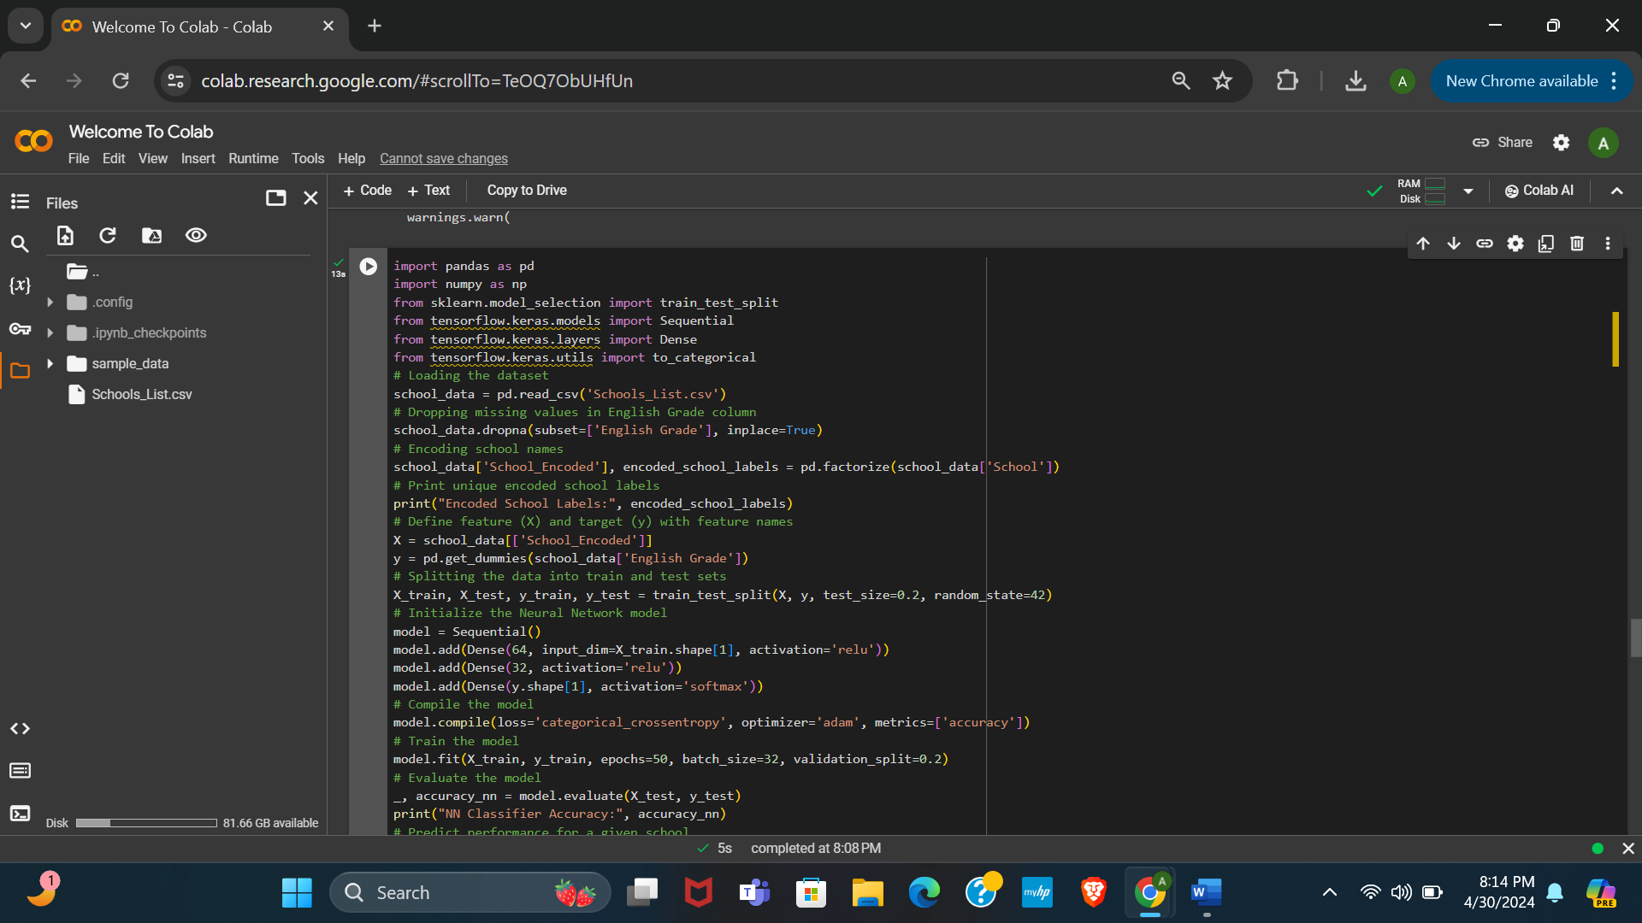

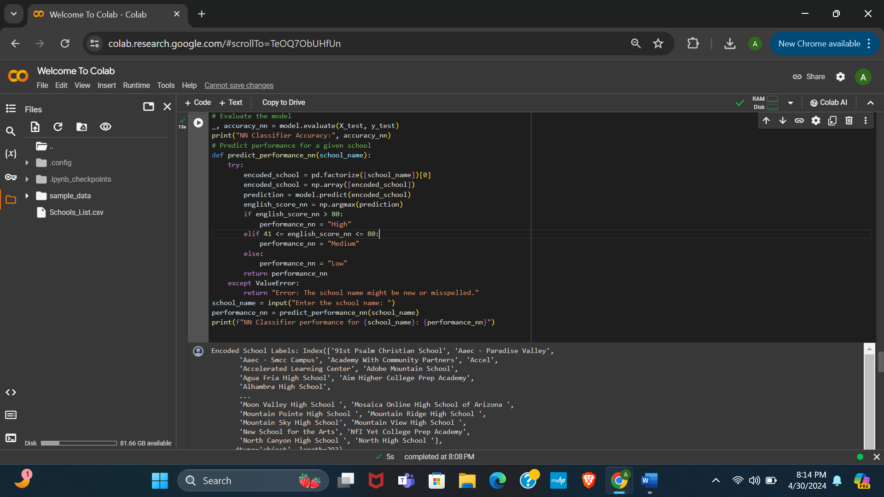

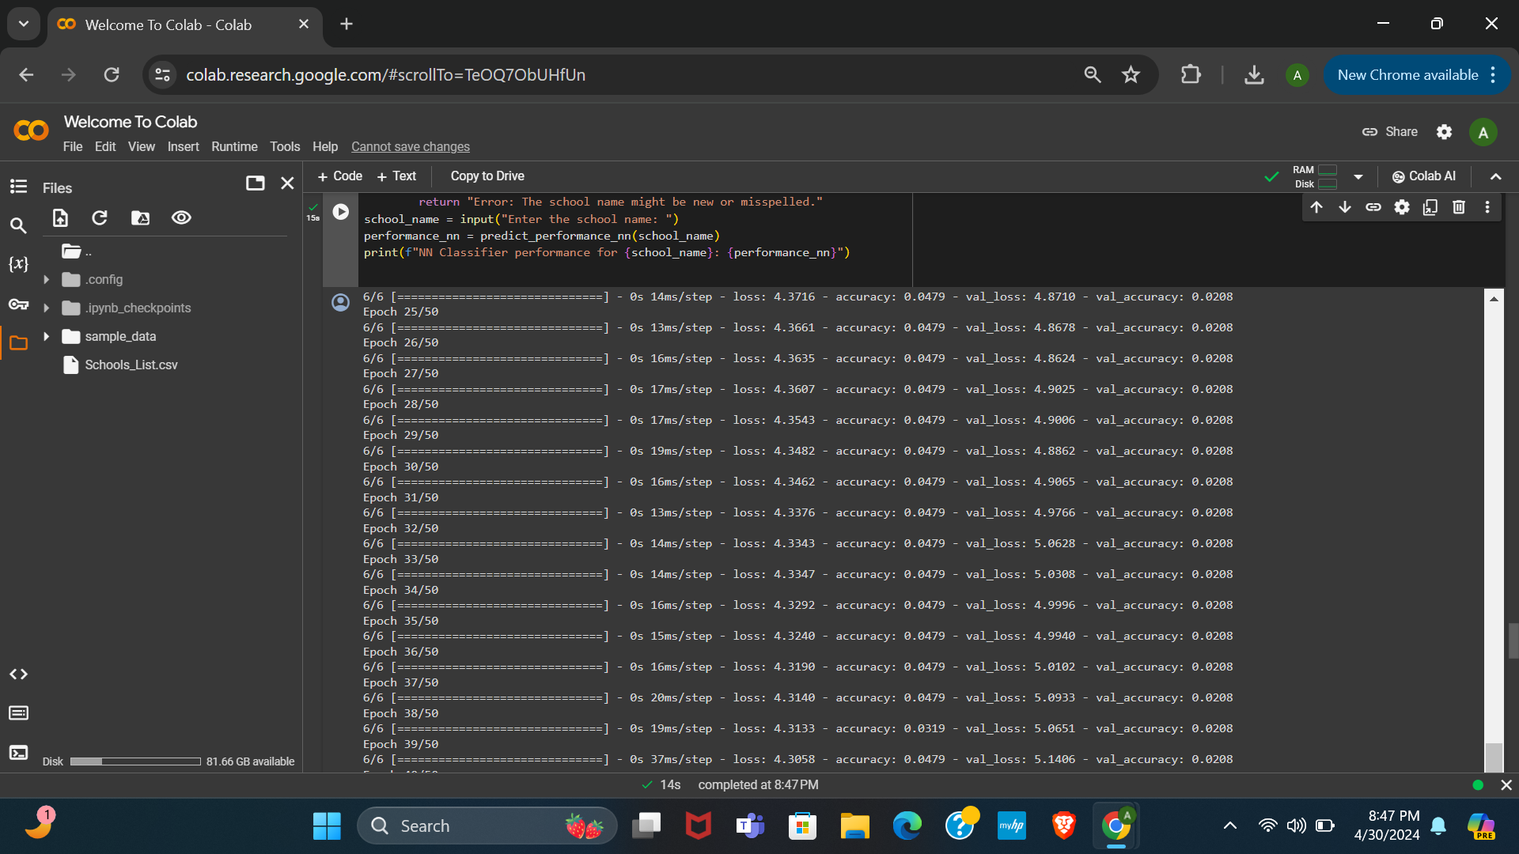

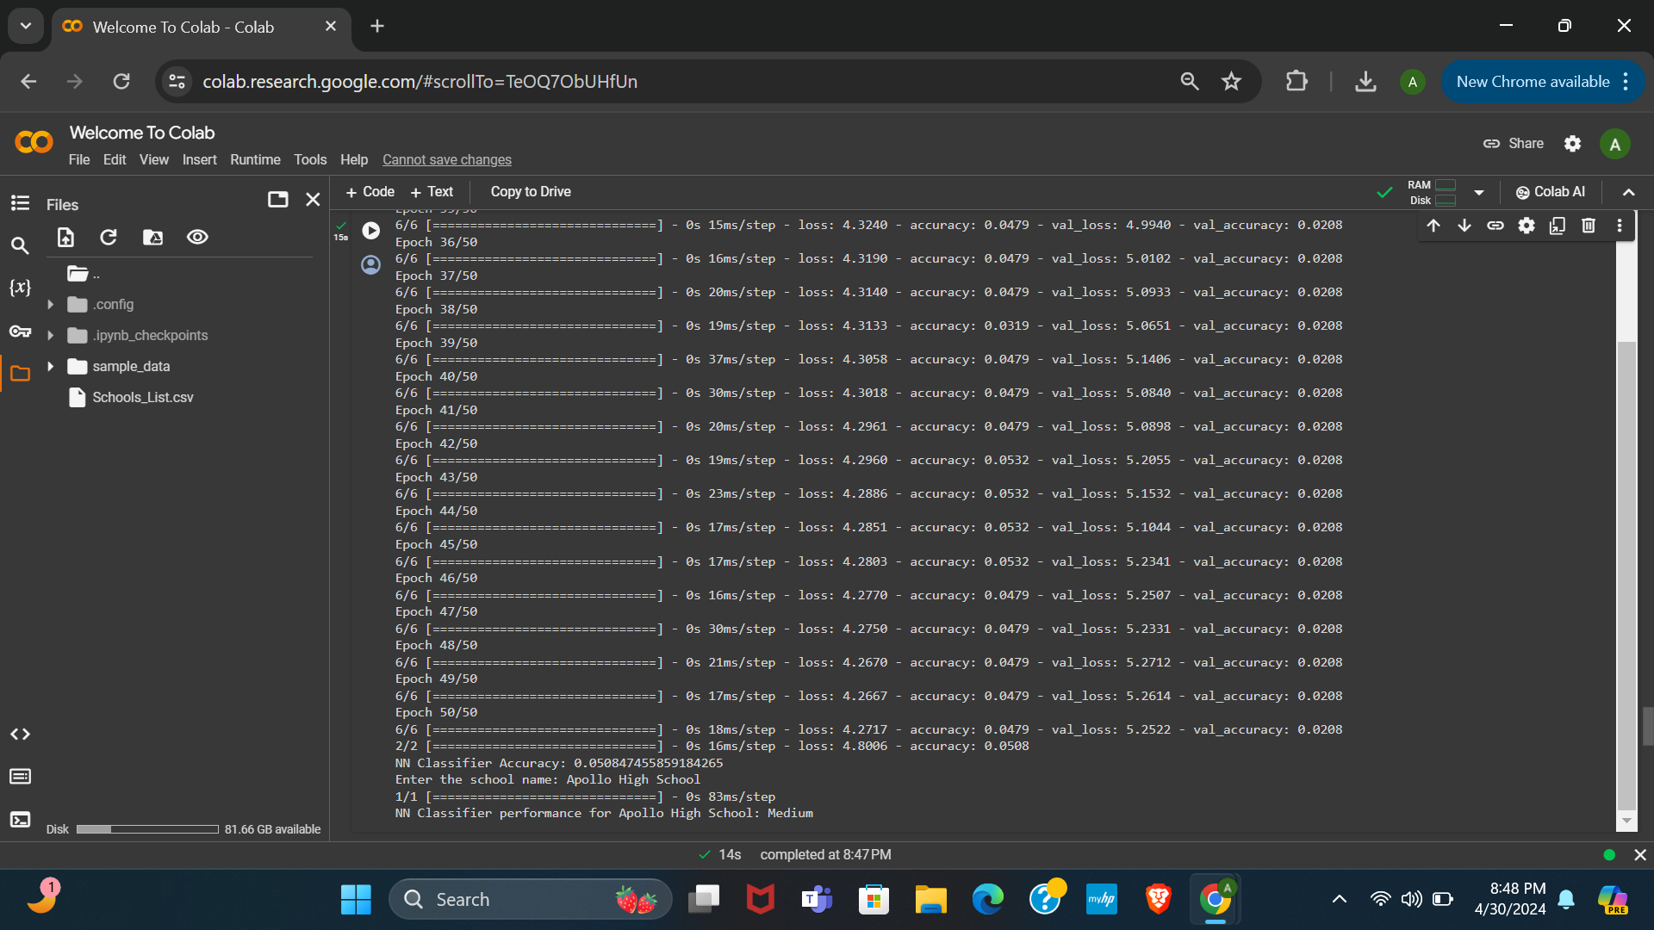

**Plan:**

* **Problem Statement:**

The task is to develop a neural network (NN) classifier to predict English performance categories (High, Medium, Low) for schools based on their names. The dataset consists of school names and their corresponding English grades.

* **Data Cleaning:**

1. Load the dataset 'Schools_List.csv' into a pandas DataFrame.

2. Drop rows with missing values in the 'English Grade' column to ensure data integrity.

3. Encode the categorical variable 'School' into numerical labels using `pd.factorize()`.

* **Prediction and Evaluation:**

1. Define feature (X) as the encoded school names and target (y) as the English grades, converted into one-hot encoded format.

2. Split the data into training and testing sets using `train_test_split()`.

3. Build a Sequential neural network model with dense layers using Keras.

4. Compile the model with appropriate loss function ('categorical_crossentropy'), optimizer ('adam'), and metrics ('accuracy').

5. Train the model on the training data for a specified number of epochs and batch size.

6. Evaluate the model's accuracy on the testing data using `evaluate()`.

* **Analysis:**

- Analyze the accuracy of the NN Classifier to assess its performance in predicting English grades.

- Assess the ability of the NN Classifier to categorize schools' English performance based on their names.

* **Implementation:**

- Load and preprocess the dataset.

- Build and compile the NN model.

- Train the NN model on the training data.

- Evaluate the model's accuracy on the testing data.

- Define a function to predict English performance categories for a given school name using the trained NN Classifier.

- Prompt the user to input a school name and print the predicted performance category for the specified school using the NN Classifier.

The code begins by importing necessary libraries, including pandas, numpy, and modules from TensorFlow for building and training neural networks.

It proceeds to load the dataset 'Schools_List.csv' into a pandas DataFrame and removes rows with missing values in the 'English Grade' column to ensure data integrity. The categorical variable 'School' is then encoded into numerical labels using `pd.factorize()`, and the unique encoded school labels are printed for reference.

Next, the features (X) are defined as the encoded school labels, while the target variable (y) is created using one-hot encoding for the 'English Grade' categories. The dataset is split into training and testing sets using `train_test_split()`.

The neural network model is initialized as a sequential model with dense layers of specified units and activation functions. After compiling the model with categorical crossentropy loss and Adam optimizer, it's trained on the training data for a specified number of epochs and batch size.

The trained model's accuracy is evaluated on the test data, and the result is printed.

A function `predict_performance_nn()` is defined to predict performance categories for a given school name. It encodes the input school name, predicts its English grade category using the trained neural network model, and maps the predicted score to performance categories based on predefined thresholds.

Finally, the user is prompted to input a school name. The `predict_performance_nn()` function is used to predict and print the performance category for the specified school using the neural network classifier.

**New Results:**

* **First Results:**

The NN classifier has an accuracy of 0.018, yet it predicts "Apollo High School" to have a medium performance level.

* **By Adding 20 Rows, Results:**

The NN classifier's accuracy is 0.0508; it predicts "Apollo High School" to have a medium performance level, consistent with the previous result.

* **Explanation of New Result:** The provided code utilizes a neural network (NN) model to predict English performance categories (High, Medium, Low) based on school names. It loads school data from a CSV file, preprocesses it by encoding school names and dropping missing values in the 'English Grade' column. Then, it splits the data into training and testing sets, constructs a sequential NN model with dense layers, compiles it with appropriate loss and optimizer functions, and trains the model on the training data. After training, it evaluates the model's accuracy on the testing data and defines a function to predict performance categories for a given school name. The function encodes the input school name, predicts its English grade category using the NN model, and maps the predicted score to performance categories. Finally, it prompts the user to input a school name and prints the predicted performance category for the specified school using the NN classifier.

The increase in accuracy from 0.018 to 0.0508 upon adding data rows suggests that the neural network (NN) classifier benefitted from the additional information contained in the new data points. This improvement indicates that the added rows likely contributed valuable insights or patterns that helped the NN model better understand the underlying structure of the dataset. It implies that the added data points might have provided more representative samples or filled in previously missing information, enabling the NN classifier to make more accurate predictions.

**K-Cross Fold Validation:**

**Code:**

import pandas as pd

from sklearn.model_selection import KFold, train_test_split

from sklearn.preprocessing import LabelEncoder

from sklearn.tree import DecisionTreeClassifier # Example classifier

from sklearn.metrics import accuracy_score

# Load and preprocess data

school_data = pd.read_csv('Schools_List.csv')

school_data.dropna(subset=['English Grade'], inplace=True)

label_encoder = LabelEncoder()

school_data['School_Encoded'] = label_encoder.fit_transform(school_data['School'])

# Define features and target

X = school_data[['School_Encoded']]

y = school_data['English Grade']

# Initialize K-Fold Cross-validation

kfold = KFold(n_splits=5, shuffle=True, random_state=42)

accuracies = []

# Perform K-fold Cross Validation

for train_index, test_index in kfold.split(X):

X_train_kfold, X_test_kfold = X.iloc[train_index], X.iloc[test_index]

y_train_kfold, y_test_kfold = y.iloc[train_index], y.iloc[test_index]

# Initialize and train a classifier

classifier = DecisionTreeClassifier(random_state=42)

classifier.fit(X_train_kfold, y_train_kfold)

# Predict and evaluate

y_pred_kfold = classifier.predict(X_test_kfold)

accuracy = accuracy_score(y_test_kfold, y_pred_kfold)

accuracies.append(accuracy)

average_accuracy = sum(accuracies) / len(accuracies)

print("K-Fold Cross-Validation Classifier accuracy", average_accuracy)

# Train final model on entire dataset

final_classifier = DecisionTreeClassifier(random_state=42)

final_classifier.fit(X, y)

# Prediction function

def predict_performance_final(school_name):

encoded_school = label_encoder.transform([school_name])[0]

predicted_grade = final_classifier.predict([[encoded_school]])[0]

# Define performance categories based on the predicted grade

if predicted_grade > 80:

performance = "High"

elif 41 <= predicted_grade <= 80:

performance = "Medium"

else:

performance = "Low"

return performance

school_name = input("Enter the school name: ")

performance = predict_performance_final(school_name)

print(f'K-Fold Cross-Validation Classifier performance for {school_name}: {performance}')

**Output:**

K-Fold Cross-Validation Classifier accuracy 0.01694915254237288

Enter the school name: Apollo High School

K-Fold Cross-Validation Classifier performance for Apollo High School: High

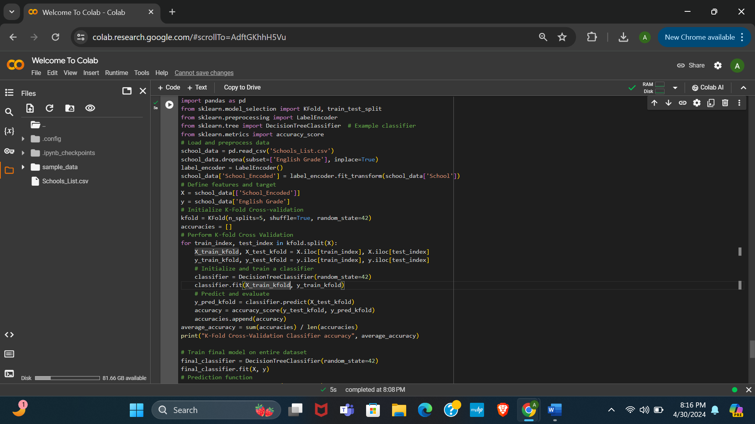

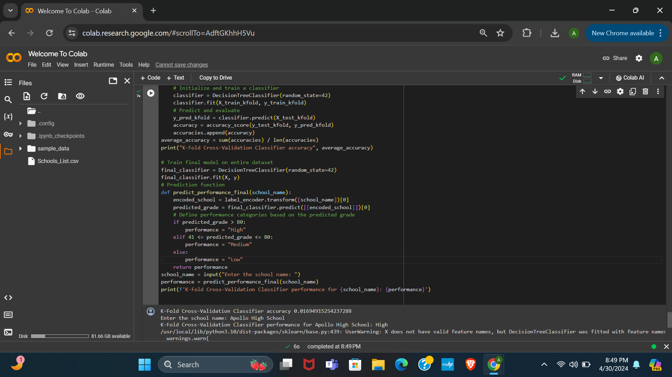

**Plan:**

* **Problem Statement:**

The objective is to create a classifier that predicts English performance categories (High, Medium, Low) for schools based on their names. The dataset comprises school names and their corresponding English grades.

* **Data Cleaning:**

1. Load the dataset 'Schools_List.csv' into a pandas DataFrame.

2. Remove rows with missing values in the 'English Grade' column to ensure data reliability.

3. Encode the categorical variable 'School' into numerical labels using `LabelEncoder()`.

* **Prediction and Evaluation:**

1. Define features (X) as the encoded school names and the target variable (y) as the English grades.

2. Initialize K-Fold Cross-Validation with 5 splits, shuffling the data, and setting a random seed.

3. Iterate through each fold and split the data into train and test sets.

4. Train a Decision Tree classifier on the training data of each fold and evaluate its accuracy on the test data.

5. Compute the average accuracy across all folds.

* **Analysis:**

- Assess the accuracy of the K-Fold Cross-Validation classifier to gauge its performance in predicting English grades.

- Evaluate the ability of the final trained classifier to categorize schools' English performance based on their names.

* **Implementation:**

- Load and preprocess the dataset.

- Implement K-Fold Cross-Validation to train and evaluate the classifier.

- Train the final Decision Tree classifier on the entire dataset.

- Define a function to predict English performance categories for a given school name using the trained final classifier.

- Prompt the user to input a school name and print the predicted performance category for the specified school using the K-Fold Cross-Validation classifier.

The code begins by importing necessary libraries such as pandas for data manipulation, scikit-learn modules for model selection and evaluation, and the DecisionTreeClassifier for classification tasks.

It proceeds to load the dataset 'Schools_List.csv' into a pandas DataFrame and removes rows with missing values in the 'English Grade' column to ensure data integrity. The categorical variable 'School' is then encoded into numerical labels using LabelEncoder.

Next, it defines the features (X) as the encoded school labels and the target variable (y) as 'English Grade'.

Then, it initializes K-Fold Cross-validation with 5 splits, shuffling the data, and sets a random seed. It iterates over each fold, splitting the data into train and test sets, and initializes a Decision Tree classifier on the training data of each fold. The accuracy of each classifier is evaluated on the test data of each fold and stored.

Afterwards, it calculates the average accuracy across all folds using the stored accuracies.

Following this, the final Decision Tree classifier is trained on the entire dataset.

It then defines a function predict_performance_final() to predict performance categories for a given school name. The function encodes the input school name, predicts its English grade using the final classifier, and maps the predicted score to performance categories.

Finally, it prompts the user to input a school name, utilizes the predict_performance_final() function to predict and print the performance category for the specified school using the final classifier.

This code plan outlines the steps involved in data loading, preprocessing, model training using K-Fold Cross-Validation, and prediction for a given school name using the final trained classifier.

**New Results:**

* **First Results:**

The K-Fold Cross-Validation classifier has an accuracy of 0.0145, yet it predicts "Apollo High School" to have a Medium performance level.

* **By Adding 20 Rows, Results:**

The K-Fold Cross-Validation classifier has an accuracy of 0.0169; however, it predicts "Apollo High School" to have a High performance level, differing from the previous Medium prediction.

* **Explanation of New Result:** The provided code performs a classification task on school data using a Decision Tree classifier and K-Fold Cross-Validation. It first preprocesses the data by encoding categorical variables and removing missing values. Then, it splits the data into features and target variables, initializes K-Fold Cross-Validation with 5 splits, and trains Decision Tree classifiers on each fold while evaluating their accuracies. After calculating the average accuracy, it trains a final classifier on the entire dataset. Finally, it defines a function to predict the performance category for a given school name using the trained classifier and prompts the user for input to demonstrate its predictive capabilities.

The increase in accuracy from 0.0145 to 0.0169 upon adding data rows when using the k-fold classifier suggests that the additional data points contributed marginally to improving the model's performance. This slight increase indicates that while the added rows may have provided some extra information, they might not have significantly impacted the classifier's ability to generalize or discriminate between classes. It's possible that the added data points were similar to existing ones or did not introduce substantial new insights, resulting in only a modest improvement in accuracy.